Daniel Paul Lassere

January 25, 1924 – July 21, 2021

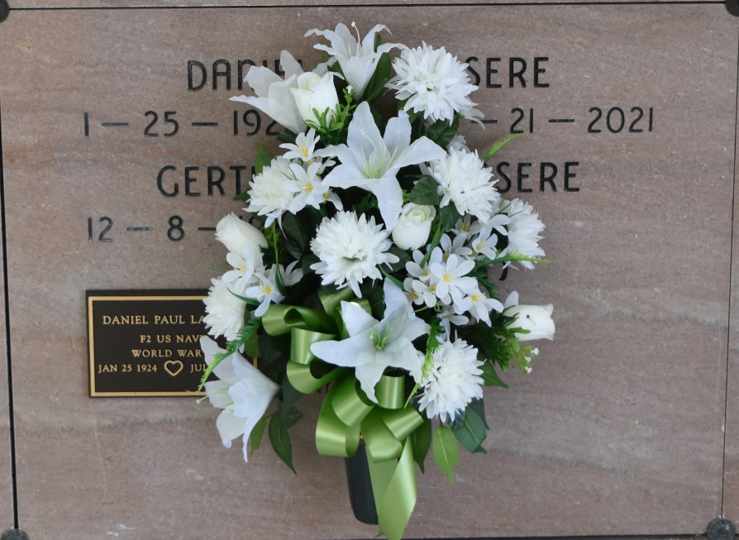

Vacherie - Daniel Paul "DP" Lassere, a native and resident of Vacherie, passed away peacefully surrounded by family on Wednesday, July 21, 2021 at the age of 97.

A private funeral service and burial will be held for his immediate family.

He is survived by his loving wife of 70 years, Gertrude "Gert" Kliebert Lassere; children, Dennis Lassere (Janice), Yvonne Lassere (Robert), Ruth Lasserre, and Lester "TS" Lassere (Leslie); grandchildren, Megan (Eric), Taylor (Kayla), Nicole (Heith), and Bryant (Brittany); great-grandchildren, Alex, Maverick, Noah, Braxton, and Cooper; siblings, Earl Lassere and Hazel Scioneaux; and numerous family members that will dearly miss him. He is also survived by his beloved grand-dog, Peaches.

He was preceded in death by his parents, Raoul and Doralise Lassere; and brother, Joseph Lasserre.

He will be remembered as a loving husband, father, grandfather, great-grandfather, brother, and a true friend to all. He was a proud US Navy veteran and served in World War II. He enjoyed gardening and being outside, tinkering with mechanics, and making everyone laugh, but most of all, he enjoyed spending time with his family and friends.

The family would like to thank his caregivers, Mary and Kim, as well as the staff at The Hospice of Baton Rouge for their care and compassion.

In lieu of flowers, donations can be made to The Hospice of Baton Rouge.

Online condolences can be given at [www.thibodauxfuneralhome.com](https://www.thibodauxfuneralhome.com/).

Houmatoday.com

July 22, 2021