Eugene Paul Lassere

July 3, 1946 - February 5, 2015

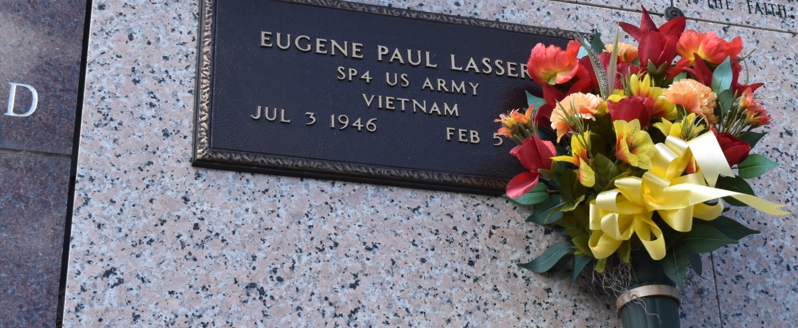

Eugene Paul Lassere, 68, passed away Thursday, February 5, 2015, at 5:25 PM at Ochsners St. Anne Hospital in Raceland, La.   
 He was a native of Vacherie, La., and a resident of Bayou Blue.  
 Visitation will be from 8:00 AM until funeral time on Saturday, February 7, 2015 at Our Lady of Peace Catholic Church in Vacherie. A Mass of Christian Burial will be at 11:00 AM Saturday at the church, with burial in the church cemetery.  
 He is survived by his daughters, Elizabeth L. (David) Naquin of Houma, Tiffany L. (Russell) Parkin of Cypress, TX, and Samantha L. (Shawn) Whitt of Lockport. He was the brother of Lorraine L. (Roy) Kraemer, Loretta L. Chenier, Ella L. Chenier and Therese L (Elves) Mars. He was the grandfather of Alexandra, Cassandra, Miranda, Victoria, and Virginia Parkin, and Amber and Baby Whitt. He was the son-in-law of Grace Maronge Benoit and the companion of Stella Gravois.  
 He was preceded in death by his wife Paula Benoit Lassere; parents, Marie Oubre and O'Neil G. Lassere; sister, Gilda Lassere Morvant; brothers, Joseph O'Neil and Adam Lassere and brothers-in-law, James Chenier, Fred Chenier and Cameron (Buddy) Morvant.  
 Thibodaux Funeral Home is in charge of the arrangements.

Unknown source