Virginia (Oubre) Lassere

1937 – November 1, 2003

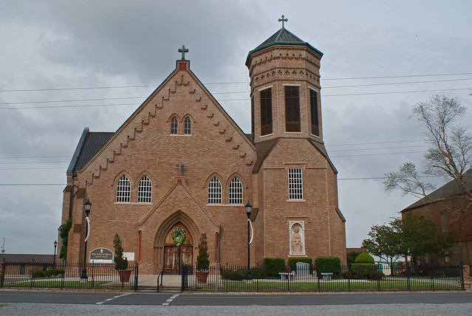

Virginia Oubre Lassere, 65, a native of Paulina and a resident of Vacherie, died at 7 a.m. Nov. 1, 2003.   
  
A Mass of Christian burial was celebrated at 11 a.m. today at Our Lady of Peace Catholic Church, with burial at the church cemetery.   
  
She is survived by her husband, John Lassere Jr.; sons, Curtis and Tracy Lassere; daughters, Vera Robertson, Elizabeth Borne, Gwendolyn Granier, Louanna Schexnayder, Sherrie Landry, Angie Lassere and Jill Tregre; sisters, Shirley Cancienne and Rose Mary Loque; 16 grandchildren; and seven great-grandchildren.   
  
She was preceded in death by her parents, Honore and Stella Poche Oubre; son, Mickey Lassere; brother, Otis Oubre; sister, Alice Oubre; and one great-grandchild.   
  
She was a parishioner of Our Lady of Peace Catholic Church.   
  
Daily Comet, Terrebonne Parish, LA; December 9, 2003