Dorothy (Keller) Laurent

November 17, 1910 – November 29, 2009

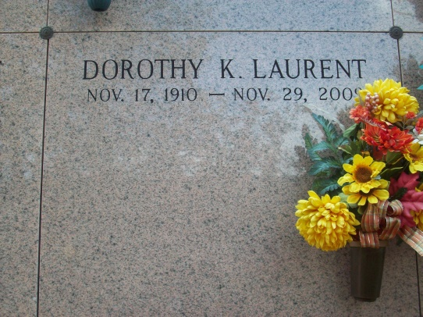

Photo by TMB

Dorothy Keller Laurent, age 99 years, in Vacherie, La., on Sunday, November 29, 2009. Born 11-17-1910. Wife of the late Simeon J. Laurent.   
 Mother of Marie Maddy L, Linda Marcia S and Errol Laurent. Daughter of the late Barthelemew and Malvina S Keller.  
 Preceded in death by 3 sons: Paul Martin Philips, Simeon A. Laurent Jr. and Paul Dickie Laurent; 4 brothers, Julius, Arthur, George and Maurry Keller, 1 sister Dora K. Chopin.   
 Sister of Genevieve K. Magee, Maria K. Harris and Rita K. Jones, 1 brother Paul B. Keller. Survived by 2 daughters-in-law, 28 Grandchildren, great grandchildren and great great grandchildren. 1 son-in-law Russel S, 1 sister-in-law Nezzie Laurent.  
 Nieces, nephews, cousins, God children, relatives, friends of the family, also Priest and Parishioners of Our Lady of Peace, St. Phillips, St. James, St. Joan of Arc (NO, La.) Catholic churches are invited to attend a Funeral Mass of Christian Burial on Wednesday, December 2, 2009 at Our Lady of Peace Catholic Church, Vacherie, La., at 11:00 A.M. Interment: Our Lady of Peace Catholic Church Mausoleum. December 01, 2009

Unknown source