Germaine Hope (Domino) Laurent

December 18, 1960 - June 6, 2017

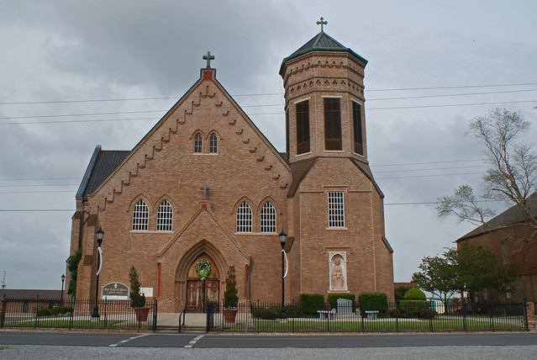

Germaine Hope Domino, native and life-long resident of Vacherie, LA., went home to be with the Lord on June 6, 2017. She was a member of Our Lady of Peace Catholic Church and its gospel choir. She was also a member of Cheris Soignet’s choir. Germaine was a 1978 graduate of St. James High School and went on to earn her Associate’s degree in Business Administration from Nicholls State University, Thibodaux, LA. She worked until 2012, the year in which she was diagnosed with stage IV colon cancer. Despite her illness, she never complained and always had a smile on her face.

She leaves to cherish her memories, husband, Keith Laurent; devoted aunts Phyllis G. Oubre and Maxine O. Borne Anderson(Raymond); mother-in-law Louise Boudoin Laurent; brother-in-law, Kenneth M. Laurent and stepson Jeremy Laurent. Germaine will also be greatly missed by her godchildren; Renata Natalia Johnson, Miyoka Nelva Monique Johnson; best friends, Sarah Isom Bradley and Angela Alexander; other relatives, Simone P. Davis(Gary), Rhoda P. Johnson, Tracy Philips, Kevin M. Philips, Janessa P. Oubre, Danielle B. Harris(Devon), Mariyah M. Davis, Gary “BaBoy” Davis and many more too numerous to mention by name.

Germaine was preceded in death by her loving parents, Clinton and Ursline Domino; sister Shelia A. Domino; grandparents Donation and Noelie Domino; Walter and Ollie Oubre and father-in-law Simon Laurent.

Parishioners of Our Lady of Peace Catholic Church, employees of Waterford 3, Motiva, Huntington Ingalls and St. James Class of 1978 are invited to attend a Memorial service in her honor at Our Lady of Peace Catholic Church on Friday, June 9, 2017 for 11:00am; 1328 LA 644, Vacherie, LA. Father Michael Miceli, Celebrant. Treasures of Life have been entrusted with her final care. 315 E. Airline Hwy, Gramercy, LA 70052.

Treasures of Life Funeral Home, Gramercy, LA; March 9, 2020