Henry Laurent

July 15, 1900 – September 9, 1990

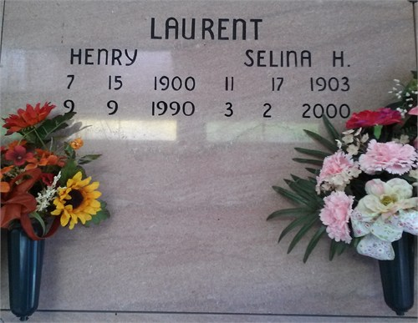

Photo by TMB

Henry Laurent died at 3 a.m. Sunday, Sept. 9, 1990, in Vacherie. He was 90, a native and resident of Vacherie. Survived by wife, Selina H. Laurent; two brothers, Maurice and Semion Laurent, both of Vacherie; three sisters, Rose and Marie Dumas, both of Vacherie, and Selina Fergerson, of New Orleans. Preceded in death by parents, Davis and Oralee Laurent; three brothers, George, Edward and Joseph Laurent; and a sister, Mary Claudia Baptiste. He was a member of Good Children's Society.

Unknown source