Kylan M. Laurent

June 28, 1989 – August 23, 2011

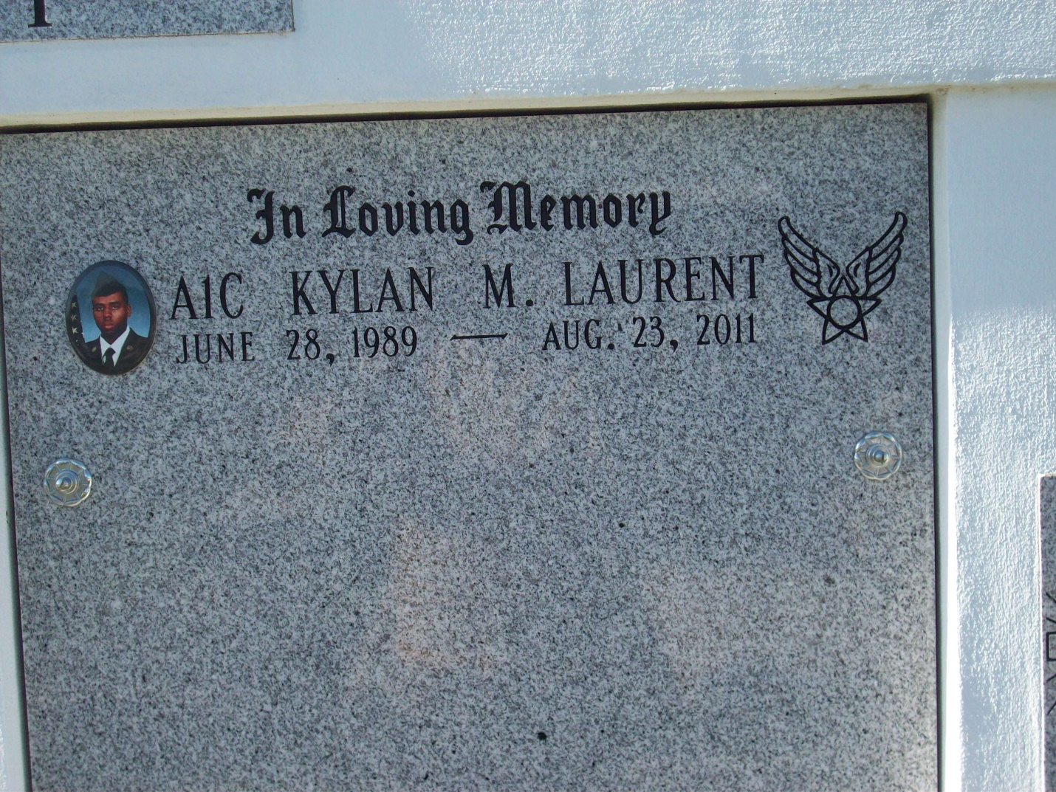

Photo by TMB

Kylan M. Laurent entered into eternal rest on August 31, 2011 at an early age of 22. He was a native of Thibodaux, LA and a resident of Vacherie, LA. Mr. Laurent was in the Air Force Reserve. He was the beloved son of Corliss Hickerson and Norris Laurent, Jr. Grandson of Norris, Sr. and Dolores Laurent, Margaret Dumas and Geraldine Smith. Stepson of Emanuel Hickerson, Jr. Father of Kaysen Payne. Brother of Nayre Laurent (John) and Chandon Hickerson. Uncle of Jaiden Ambrose. He is also survived by 4uncles, 4 aunts, a host of other relatives and friends. Relatives and friends of the family are invited to attend the Mass of Christian Burial at St. Phillip Catholic Church on Hwy 18 in Vacherie, LA on Friday, September 9, 2011 at 11:00am. Visitation from 9-11:00am. Rosary will begin at 9:45am. Interment Our Lady of Peace Cemetery, Vacherie, LA. Arrangements by Rhodes United fidelity Funeral Home, 2929 Scenic Hwy, Baton Rouge, LA. Please visit [www.rhodesfuneral.com](http://www.rhodesfuneral.com/) to sign the guest book.

The Times-Picayune, New Orleans, LA

September 8, 2011