Louise A. (Boudoin) Laurent

September 30, 1938 – May 6, 2018

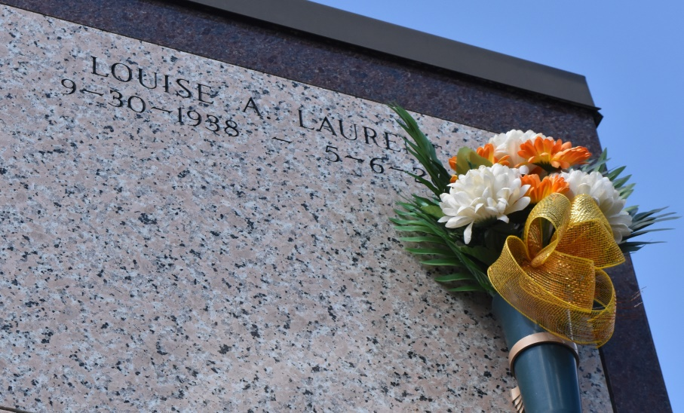

Louise (Pic) (Weezy) Boudoin Laurent, a native of Edgard, LA, and a resident of Vacherie, LA on Sunday, May 06, 2018, at 3:56pm at West Jefferson Medical Center, transitioned to her heavenly home, age 79 years old. She leaves to cherish her memories, two sons; Keith Andrew and Kennith Michael. Preceded in death by her husband, Simeon Laurent, Jr; parents Sylvio and Eunice Boudoin; brothers Albert Boudoin Sr., Gerald Boudoin, Sr., Joseph Louis Boudoin, Sr., sisters; Gustavia Jones, and Frances Boudoin. She is survived by her sisters Geraldine Boudoin Smith, Margaret Boudoin Dumas, Jessie Boudoin Keller, sister-in-law Marie Lewis, Linda (Russell) Steib, a host of nieces and nephews, grandchildren Jeremey Joseph Laurent, Grant Micheal Laurent, Lauren Michelle Laurent, and Kira Star Laurent. Retired employee of West Jefferson Medical Center for 37 years. Relatives, friends, Second Ward High School Class of 1957, West Jefferson Medical Center, and Chez-Elma Adult Day Care are invited to attend a mass of Christian burial on Thursday, May 10, 2018 at Our Lady of Peace Catholic Church, 13281 LA-644, Vacherie LA. Visitation at 8:30 am followed by a mass of Christian Burial at 11:00 am, recitation of the rosary 9:30 am. Officiated by Father Brad Doyle. Entombment church mausoleum. Treasures of Life Funeral Services, 315 E. Airline Hwy, Gramercy, Louisiana was entrusted with her final care.

The New Orleans Advocate (LA)

May 8 to May 10, 2018