Selina (Harry) Laurent
November 17, 1903 - March 2, 2000

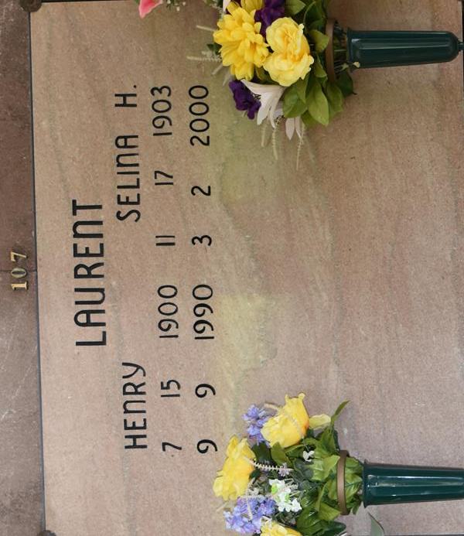

Died Thursday, March 2, 2000, at Audubon Guest House, Thibodaux. She was 96 and a native of Vacherie.

Visiting at Our Lady of Peace Catholic Church, Vacherie, from 9 a.m. Saturday until religious services at 11 a.m. Entombment in the church mausoleum.

Survived by a brother, Willie Harris, Grosse Tete; and many nieces, nephews, other relatives and friends. Preceded in death by her husband, Henry Laurent; parents; a sister; and two brothers. Williams & Southall Funeral Home, Napoleonville, in charge of arrangements.

Advocate, The (Baton Rouge, LA)
Friday, March 3, 2000

