Simeon A. Laurent Jr.

November 30, 1937 – August 3, 2008

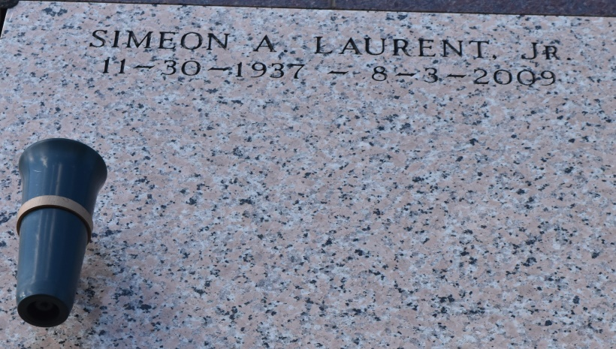

Simeon A. Laurent Jr., 71, a native and resident of Vacherie, La., died Monday, Aug. 3.

He is survived by his beloved wife, Louise Boudoin Laurent; mother, Dorothy K. Laurent; two sons, Keith A. Laurent and Kennith M. Laurent; three siblings, Marie Maddy Lewis, Linda Marcie Steib and Errol F. Laurent, all of Vacherie; three grandchildren, Jeremy, Grant and Lauren Laurent; father-in-law, Germaine D. Laurent and wife Gogi Laurent; five sisters-in-law; four brothers-in-law; three aunts; one uncle; and a host of nieces, nephews and cousins.

He was preceded in death by his father, Simeon J. Laurent; and two brothers, Paul Martin Philips and Paul Dick Laurent.

Visitation will be 8 a.m. to 10 a.m. Thursday, August 6, at Our Lady of Peace Catholic Church in Vacherie. Mass will be at 10 a.m. Thursday at the church with interment at the church cemetery. Thibodaux Funeral Home is in charge of the arrangements.

Houmatimes.com

Posted Wednesday, August 5, 2009