Simeon J. Laurent

February 14, 1911 – October 3, 2008

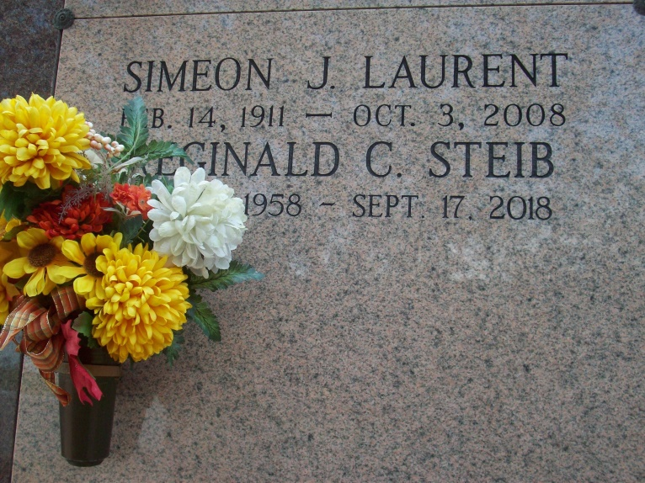

Photo by TMB

Simeon J. Laurent, 97, a native and resident of Vacherie, La., died Friday, October 3.

He is survived by his wife, Dorothy Keller Laurent; two daughters, Marie Maddy Lewis and Linda M. Steib; two sons, Simeon A. and Errol Laurent of Vacherie; two daughters-in-law, Joyce Philips and Louise Laurent; four sisters-in-law, Maria Harris, Rita Jones, Genevieve Magee and Nezzie Laurent; one son-in-law, Russel Steib; 35 grandchildren; 37 great-grandchildren; three great-great-grandchildren; and numerous relatives.

He was preceded in death by his parents, Davis and Auralie Steib Laurent; five brothers, Henry, George, Joseph, Maurice and Edward Laurent; four sisters, Rose and Sadie Dumas, Selena Fergerson and Cloudia Baptist; two sons, Martin Philips and Dickie Laurent; and two grandsons, Erwin Steib and Renard Green.

Interment was at Our Lady of Peace Catholic Church Mausoleum in Vacherie. Thibodaux Funeral Home is in charge of the arrangements.

Houmatimes.com

Posted Tuesday, October 7, 2008