Adelina (Becnel) Legendre

September 20, 1936 – April 7, 2018

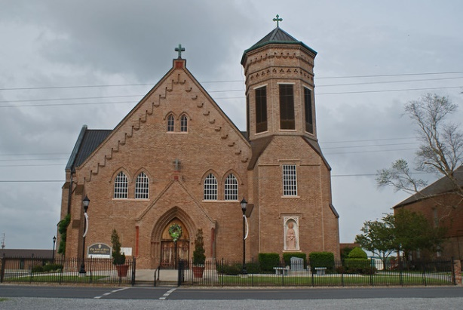

Adelina Becnel Legendre, 81, passed away peacefully surrounded by her family on Saturday, April 7, 2018 at 5:32 p.m. Born, September 20, 1936 she was a native of Vacherie and resident of Chackbay.   
 Visitation will be held on Tuesday, April 10, 2018 from 10 a.m. until service time at Life Tabernacle Church in Chackbay (Life Church). Funeral Service will begin at 12 p.m. at the church with burial following at Our Lady of the Peace Cemetery in Vacherie.  
 She is survived by her sons, Avery Joseph "A.J." Legendre and wife, Mary, Irving Joseph Legendre Jr.; daughters, Trudy Usey and husband, Pastor Dale R. Usey and Naomi Campbell and husband, John Campbell Jr.; grandchildren, Janelle (Shannon) Kendrick, Jeremy (Shelby) Usey, Carlos Legendre, Avery Legendre, Jr., Brittney (Michael) Blanchard, Dalton Blanchard, Heidi Legendre, and Daniel Usey; great-grandchildren, Hailey, Bayley, Baylen, Bentyn, Noah, Caiden, Jase and Kathleen; brothers, Gustave Becnel and Patrick Becnel; sisters, Beulah Triche and Gloria Stein; godchildren, Wilson Becnel and Fanny Cranford.   
 She is preceded in death by her husband of 57 years, Irving Legendre Sr.; parents, Roseluis "Pep" Becnel and Fannie Dempster Becnel; brothers, Maurice "Wag", Francis and Leopold Becnel.   
 Adelina was a very Christian women who loved attending church. She enjoyed working in her gardens and her flowers.   
 The family would like to thank Saint Joseph Hospice.  
 Ordoyne Funeral Home is in charge of arrangements.

Published in Houma Today & The Daily Comet, Terrebonne Parish, LA from Apr. 8 to Apr. 9, 2018