Chester Joseph Louque Jr.

December 9, 1952 – October 2, 2020

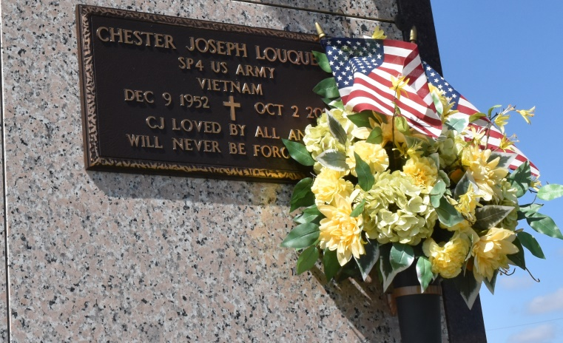

     Chester “CJ” Louque, Jr. born December 9, 1952 and passed away October 2, 2020 at 67 years old.  He fought the great fight until the very end.  He loved life to the fullest and time spent with family.   He enjoyed cooking, gardening, the casino, football including both Saints and LSU, crabbing, fishing, hunting, riding motorcycles, and playing the guitar.  He also loved his Bud Light.  After proudly serving our country, he was honorably discharged from the United States Army.  CJ was a helper and giver to all who needed, and always there for everyone.

     He was survived by Gayle Bryant Louque, beloved wife of 13 years.  He left behind 5 children: Tatum Callahan (Darin), Wesley Louque, Lance Louque, Lisa Duet (Gavin) and Jessica Balatico (Christopher); 6 grandchildren, Dalton Lions, Hannah Callahan, Madison Louque, Gabrielle Louque, George and Logan Duet; 3 Godchildren, Jeremy Stout, Hailey Martin Moran, and Fabian Louque; 4 sisters, Joan Bourgeois, Gwen Miano, Pat Trosclair, Deborah Waguespack; and brother Kevin “Puggy” Louque.  Two very special people in his life were his father-in-law Larry “Pop” Becnel and mother-in-law Ruth “Mom” Becnel.

     He was preceded in death by his parents, Chester and Ethel Louque, Sr.; and sister Lorraine Guidry.

     A visitation will be held Tuesday, October 6, 2020 at Rose Lynn Funeral Home in Lutcher, LA from 8:00 am to 11:30 am.  A Mass of Christian Burial will follow at Our Lady of Peace in Vacherie, LA beginning at 12 noon.  Burial will follow in the church cemetery.

Rose Lynn Funeral Home

Lutcher, Louisiana