Lorine “Irene” (Keller) Lumas

August 26, 1915 – September 15, 2004

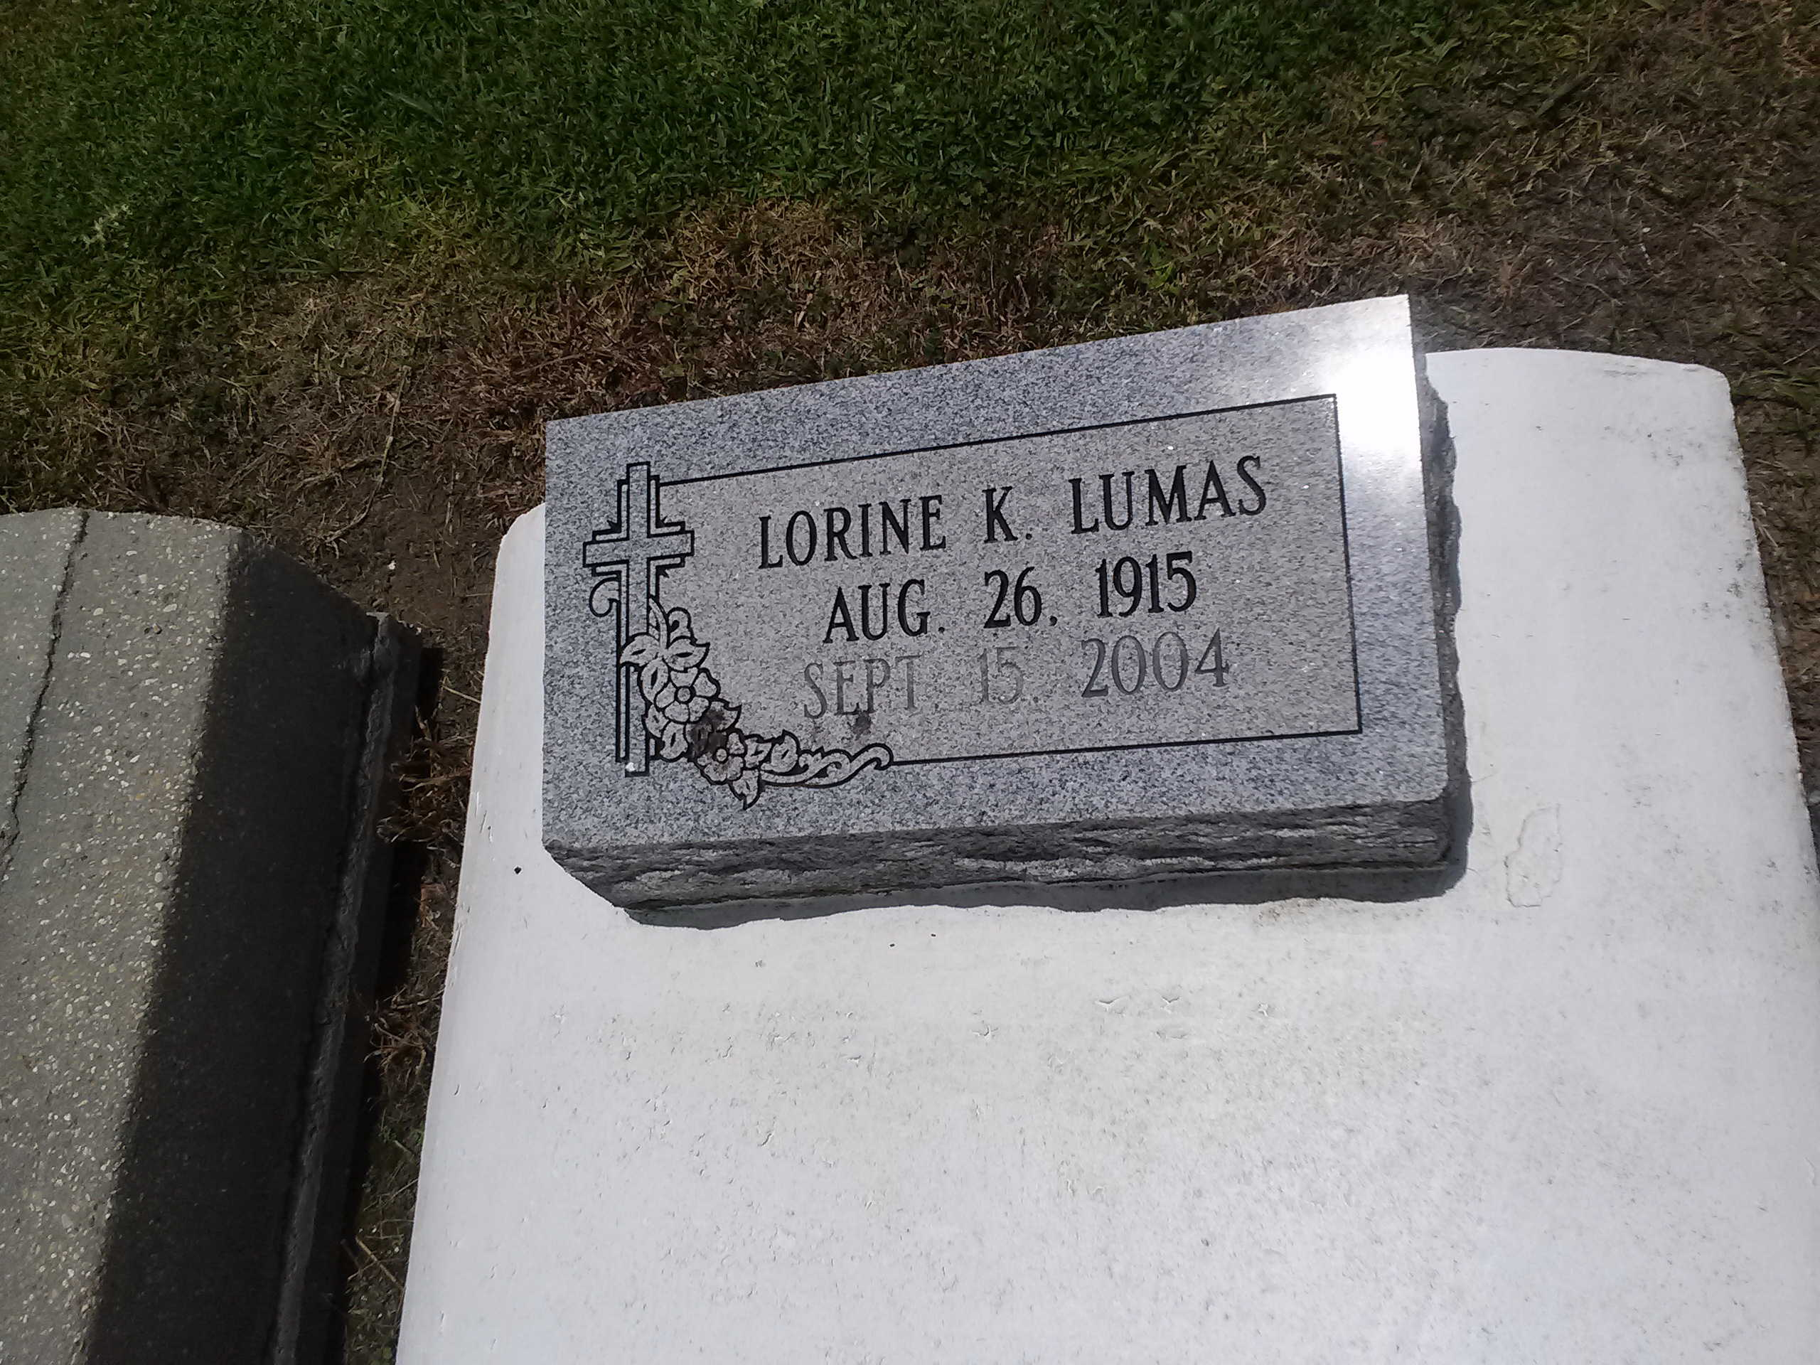

Photo by TMB

Lorine "Irene" Lumas, a homemaker, died Wednesday at Meadowcrest Hospital. She was 89. Mrs. Lumas was born in Vacherie and lived in Gretna. She was a parishioner of All Saints Catholic Church for more than 50 years. She was a member of the Knights of Peter Claver, St. Rita Court No. 36 Ladies Auxiliary. Survivors include a son, Joseph Milton Lumas; three daughters, Jessie Mae L. Felix, Stella Mae L. Thompson and Mary Ethel L. Rogers; two brothers, Joseph Elliot and Victor Keller; two sisters, Corrine K. Love and Cecile K. Mundy; 52 grandchildren; 90 great-grandchildren; and 20 great-great-grandchildren. A Mass will be said today at 10 a.m. at All Saints Catholic Church, 1441 Teche St., Algiers. Visitation will begin at 8 a.m. Burial will be in Our Lady of Peace Cemetery in Vacherie. D.W. Rhodes Funeral Home is in charge of arrangements.

Times-Picayune, The (New Orleans, LA)

Tuesday, September 21, 2004

Contributed by Jane Edson