Frances (Lacaze) Marino

June 16, 1918 – May 30, 2008

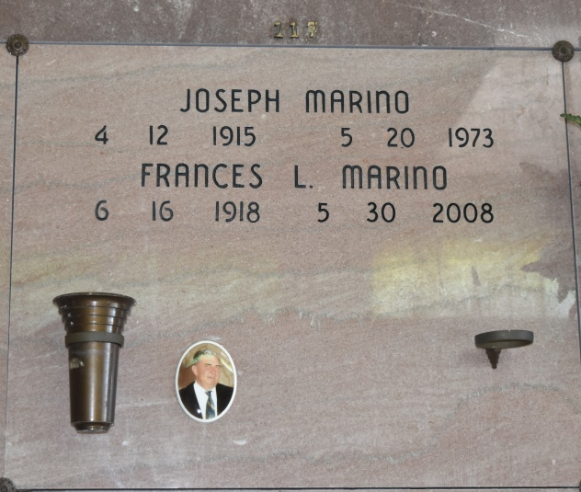

A resident of Thibodaux, she died at 9:08 a.m. Friday, May 30, 2008. She was 89, born June 16, 1918, in Vacherie. Visiting at Thibodaux Funeral Home chapel in Thibodaux on Sunday, June 1, from 6 p.m. to 9 p.m. Visiting continues at Our Lady of Peace Catholic Church in Vacherie on Monday, June 2, from 8 a.m. until Mass of Christian Burial at 11 a.m. Interment in Our Lady of Peace Cemetery. She is survived by two sons, Donald Marino and wife Madeline and Sam Marino; a daughter, Lynn Marino Gravois and husband Ernest; a sister, Catherine Kay; 10 grandchildren, Joey Gravois Hunt, Lee Michelle Gravois, Joseph Marino, Charles Marino, Donald Marino Jr., Paul Marino, Patty Marino, Ricky Marino, Gregory Marino and Nicole Radgowski; 13 great-grandchildren and numerous nieces, nephews and her loving cat, Bubba. She was preceded in death by her husband, Joseph Marino; parents, Louis Lacaze and Lessie Johnette Lacaze; a daughter-in-law, Diane Marino; five brothers, J.L. Lacaze, J.P. Lacaze, Elmer Lacaze, Dudle Lacaze and Grady Lacaze; and a sister, Josephine Robinson.

The Advocate, Baton Rouge, Louisiana

June 1, 2008