Bernard Joseph Marse

September 27, 1931 – April 9, 2010

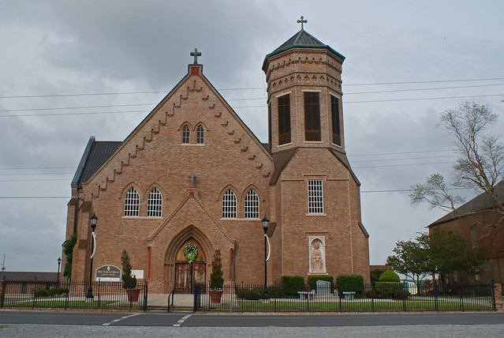

Bernard Joseph Marse, 78, a native and resident of Vacherie, was born on Sept. 27, 1931 and passed away on Friday, April 9, 2010.   
 Visitation will be from 7:30 a.m. to funeral time Tuesday at Our Lady of Peace Catholic Church in Vacherie. Mass will be 11 a.m. Tuesday at the church, with burial in Our Lady of Peace Cemetery.   
 He is survived by one son, Todd Marse and wife, Stephanie; two daughters, Cheryl M. Reulet and husband, David (BIM), and Rhonda M. Folse and fiancé, David Simon; two sisters, Claire "P-Nut" Gauthreaux and Augustine "Teen" M. Hymel and husband, Kelsey; four grandchildren, Nicholas and Nicole Folse, Michelle Reulet and Tyler Marse; and one great-grandchild, Carter Myers.   
 He was preceded in death by his parents, Severas Sr. and Procla Falgoust Marse; three brothers, Augustin, Leonard and Severas Jr. Marse; and two sisters, Rita M. Delatte and Bernadette M. Tregre.  
 He was an employee of Avondale Shipyards for 34 years.  
 Rose Lynn Funeral Services is in charge of the arrangements.

Unknown source