James John Marse Jr.

January 11, 1929 – September 24, 2005

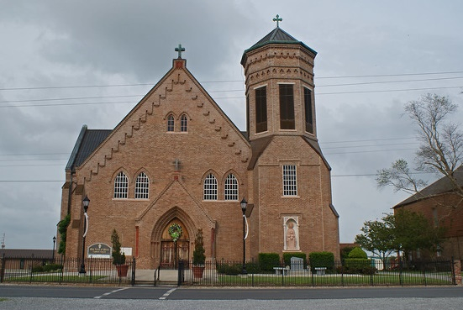

James John Marse Jr. died at 12:25 p.m. Saturday, Sept. 24, 2005, at Our Lady of the Lake Regional Medical Center. He was 76, a native of Vacherie and a resident of Metairie for 57 years.   
 He was the beloved husband of Virgie Troxclair Marse, father of Lisa M. Corkern of Metairie, grandfather of Derek J. DeVought, father-in-law of Stephen Corkern, son of the late James J. Marse Sr. and Therancia Falgoust Marse, and brother of Josephine M. Ballanga, Isabel M. Dellatte, Cecile M. Simon, Cecilia M. Weber, Edna M. Rougee and the late Gaston and Philip Marse.   
 Relatives and friends of the family, employees of Marse Welding Supplies Inc. of Metairie and parishioners of St. Philip Neri Catholic Church of Metairie are invited to attend the funeral Mass at Our Lady of Peace Catholic Church, 13281 La. 644, Vacherie, at 1 p.m. Tuesday, Sept. 27. Entombment in Our Lady of Peace Mausoleum, Vacherie. Visitation at Our Lady of Peace Catholic Church on Tuesday, Sept. 27, after 9:30 a.m. until Mass.   
 H.C. Alexander Funeral Home, Lutcher, is in charge of arrangements.   
  
Published in The Advocate, Baton Rouge, LA on September 26, 2005

Contributed by Karen Klem Pinckard