James John Marse Sr.

September 1, 1893 – June 24, 1962

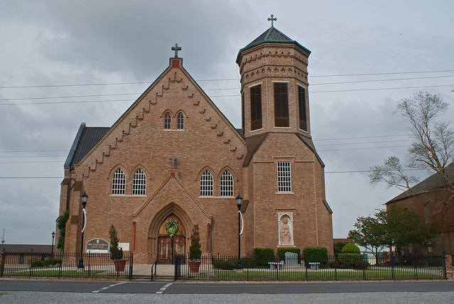

In Vacherie, Louisiana, on Sunday, June 24, 1962, at 12:30 o’clok p.m. James J. Marse Sr., beloved husband of the late Therancio Falgoust, father of Ga-io- Marse, Mrs. Josephine Balianca, James Marse Jr.; all of New Oleans, La., Mrs. Edna Rougee, Philip Marse, Mrs. Isabell Delatte, Mrs. Cecile Simon and Mrs Cecilia Webre, all of Vachie, La.; brother of Wilfred and Abel Marse, Mrs. Eulie Rome, Mrs. Lorine Rodrigue and Mrs. Tesia Folse, also survived by 2? Grandchildren and 5 great-grandchildren, age 68 years9 months, a native and a resident of Vacherie, La.

Relatives and friends of the family are invited to attend the funeral.

Services from the Knights of Columbus Home, Vacherie, La., on Tuesday, June 27, 1962, at 9:40 o’clock a.m. followed by religious services at Our Lady of Peace Catholic church, Vacherie, La., at 10 a.m. Interment in church cemetery.

Home will be open after 11 a.m., Monday.

Arrangements by Landry Montz funeral Home, Donaldsonville, La.  
  
Published in The Times Picayune, New Orleans, LA on June 26, 1962

Contributed by Charlotte Graves