Kristi (Falgoust) Marse

April 8, 1971 - November 7, 2015

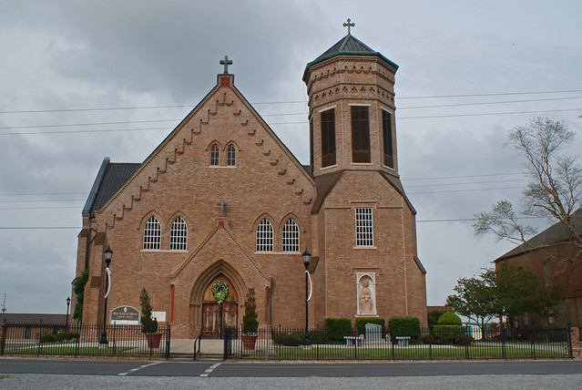

Kristi Falgoust Marse, 44, died on Saturday, November 7, 2015. She is survived by her loving husband of 19 ½ years, Heath Marse; two daughters, Lexi and Karli Marse; mother, Cheryl Simon; father, Donald Falgoust; mother-in-law and father-in-law, Linda and Carrol Marse; one brother, Todd Falgoust; Godchild, Britney Schexnayder and husband, Shawn; two nieces, Kayla Falgoust and Rebecca Falgoust; two nephews, Cody Oubre and Chase Ordoyne; and one great niece, Raygen Schexnayder. Preceded in death by maternal grandparents, Leo and Shirley Simon; paternal grandparents, Antoine and Thelma Falgoust; one sister, Mitzi Falgoust Oubre; and one niece, Mary Oubre. Visitation will be held on Friday, November 13, 2015 at 9:00 a.m. until Mass of Christian Burial at 11:00 a.m. at Our Lady of Peace Catholic Church in Vacherie. Internment to follow in church mausoleum. Arrangements by Ourso Funeral Home in Donaldsonville. To offer condolences to the family, please sign the online guestbook at www.oursodonaldsonville.com.  
  
Ourso Funeral Home, Donaldsonville, LA