Procla (Falgoust) Marse

March 12, 1900 – May 8, 1980

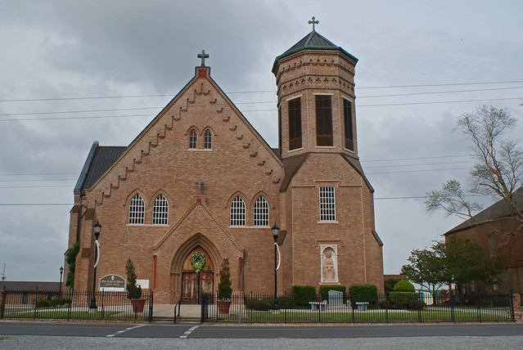

Marse, Procla Falgoust

Died at 10:30 p.m. Thursday, May 8, 1980, in Vacherie. She was 80, a native and resident of Vacherie. Visiting at Our Lady of Peace Catholic Church, Vacherie, from 8 to 10 a.m. Saturday. Religious services at the church at 10 a.m. Saturday. Burial in the church cemetery. Survived by four daughters, Mrs. William (Rita) Delatte, Mrs. Alcide (Bernadette) Tregre, Mrs. Ed (Claire) Gauthreaux and Mrs. Kelsey “Teen” Hymel, all of Vacherie; two foster daughters, Cheryl and Rhonda Marse, both of Vacherie; two sons, Jean Augustin Marse, Chackbay, and Bernard Marse, Vacherie; foster son, Todd Marse, Vacherie; two sister, Mrs. Maria Gravois and Miss Augustine Falgoust, both of Vacherie; 24 grandchildren; 23 great-grandchildren. Preceded in death by her husband, Severas Marse Sr., two sisters, Miss Margarette Becnel and Theracia Marse; a brother, Joseph Falgoust. Thibodaux Funeral Home is in charge of arrangements.  
  
The Advocate, Baton Rouge, LA; May 10, 1980, p. 10

Contributed by Charlotte Graves