Severas Marse

December 30, 1899 – August 8, 1953

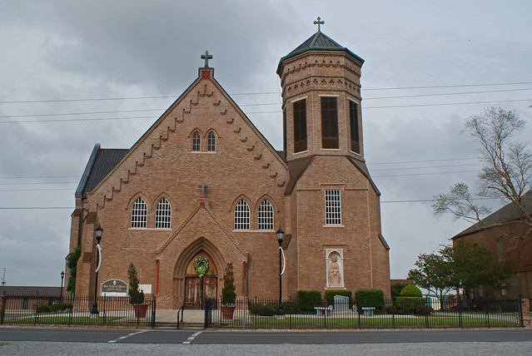

Marse – At his residence, Vacherie, La., on Saturday, August 8, 1953, at 3 a.m. Severas Marse, beloved husband of Procla Falgoust, father of Mrs. William Delatte, Mrs. Alcide Tregre, Mrs. Ed Gautreaux and Augustine Marse, Jean Augustine, Bernard Severas Jr. and Leonard Marse, all of Vacherie, La., also survived by nine grandchildren, aged 53 years, a native of St. James parish, La.

Relatives and friends of the family are invited to attend the funeral, whill will take place from the late residence on Sunday, August 9, 1953, at 4 p.m. Religious services at Our Lady of Peace Catholic church, Vacherie, La.

Interment in Our Lady of Peace Catholic cemetery

Thibodaux Funeral Home, Thibodaux, in charge.

The Times Picayune, New Orleans, LA; August 9, 1953, p. 16

Contributed by Charlotte Graves