Ethel (Chopin) McKnight

March 28, 1942 – August 23, 2001

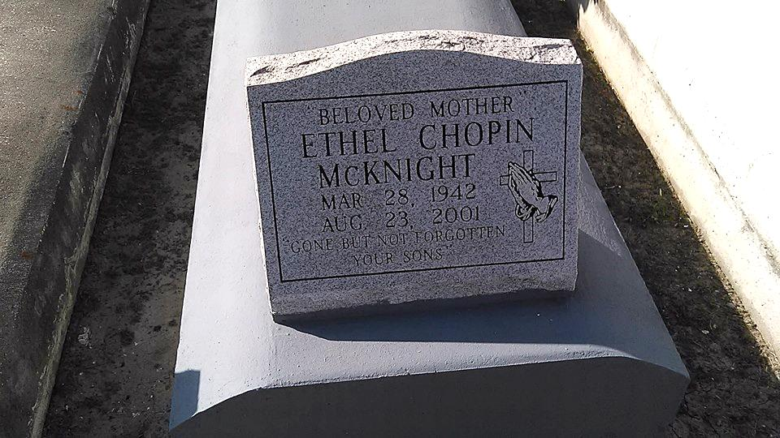

Photo by TMB

Ethel Chopin McKnight, a homemaker, died Thursday of cardiac arrest at University Hospital. She was 59. Ms. McKnight was born in Vacherie and lived in Marrero for many years.

Survivors include three sons, Elliot and Melvin McKnight and Edgar McKnight III; four brothers, Ivan, Alvin and Calvin Chopin and Edward Chopin Sr.; three sisters, Rosemary Wafford, Bessie Oubre and Josephine Jacks; and 10 grandchildren.

A Mass will be said Wednesday at 11 a.m. at Our Lady of Peace Catholic Church, 13281 Louisiana 644, Vacherie. Visitation will begin at 9 a.m. Burial will be in the church cemetery. Davis Mortuary Service is in charge of arrangements.

Times-Picayune, The (New Orleans, LA) - Tuesday, August 28, 2001