Antoine Anicest Melancon

November 2, 1930 – November 26, 2020

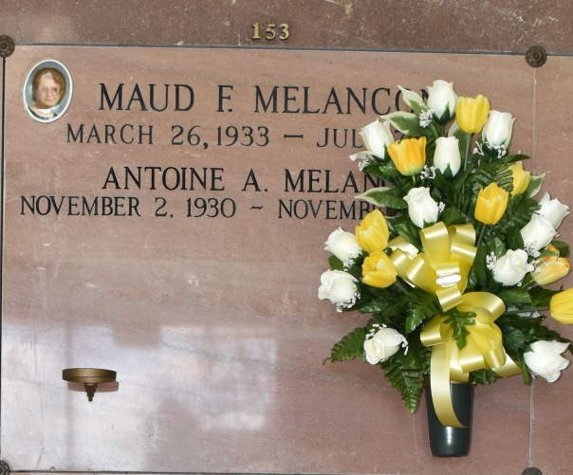

Antoine Anicest Melancon, 90, a loving father and grandfather, a native of Paulina, LA and resident of Vacherie, LA passed away peacefully on Thursday, November 26, 2020.  
 A visitation will be held in his honor on Tuesday, December 1, 2020 at Thibodaux Funeral Home, Thibodaux, LA from 8:30 am until 10:00 am. A Mass of Christian Burial at 11:00 am will be held at Our Lady of Peace Catholic Church in Vacherie, LA. The burial will follow in Our Lady of Peace Cemetery, Vacherie, LA.  
 He is survived by his four children, daughters, Deborah Rodrigue and Norma Labat (Howard); sons Kirk Melancon (Veronica) and Ted Melancon (Rayann); eight grandchildren, Beau Rodrigue (Tammy), Paul Labat, John Labat (Alissa), Ryan Melancon (Haley), Chad Melancon, Ashley Melancon, Blake Melancon, Cameron Melancon; two great-grandchildren, Charlee and Lane Melancon; sister, Julia M. White and numerous nieces and nephews.  
 He was preceded in death by his wife, Maud F. Melancon; parents, Walter J. Melancon and Olympe Vicknair Melancon; brothers, Louis, O'Neal, Clarence, Walter (Buck); infant brothers, George, Numa, Floyd and Lloyd Melancon; sisters, Elia Lambert, Delia Lambert, Elsie Abney, and son-in-law Manuel J. Rodrigue.  
 He served in the United States Army, was a life time member of the V.F.W. and worked at Lions Oil/Monsanto for 30+ years. He was an avid gardener, enjoyed watching LSU/Saints football and old western shows.  
 The family would like to thank Father Vincent Dufresne for the prayers and blessings bestowed upon their beloved father. They would also like to thank the staff and nurses at Thibodaux Regional Hospital, AMG Specialty Hospital, Chateau St. James, and Modern Hospice for their loving care and compassion of their father.  
 Online condolences can be given at www.thibodauxfuneralhome.com  
Thibodaux Funeral Home, Inc. is in charge of arrangements.  
  
Houma Today, Terrebonne Parish, Louisiana

Nov. 28 to Nov. 30, 2020