Ferdinand Melancon

February 15, 1923 – July 6, 2006

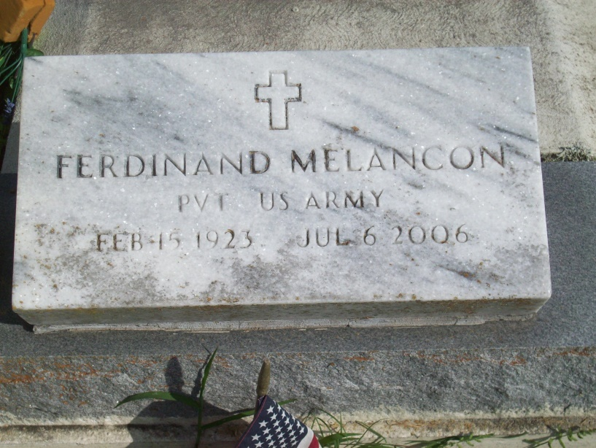

Photo by TMB

Ferdinand Melancon, at St. James Parish Hospital, Lutcher, LA, at 3:26 p.m., Thursday, July 6, 2006. Son of the late Alexander Melancon, Sr. and Lorenza Steib Melancon. Husband of the late Mamie Smith Melancon. Brother and brother-in-law of Eva Mae and Lawrence Hall, Virginia Williams, Lorenza Favorite, Henry Melancon, the late Rita Carter, Emily Weatherspoon, Joseph and Alexander Melancon, Jr. Also survived by numerous nieces, nephews, cousins, other relatives and friends. Age 83. Visiting at St. James Catholic Church, St. James, LA, Saturday, July 15, 2006 from 9:30 a.m. until Mass of Christian Burial at 11:00 a.m. Conducted by the Rev. Louis Oubre. Interment in Our Lady of Peace Cemetery, Vacherie, LA. BRAZIER-WATSON FUNERAL HOME in charge of arrangements.

The Times-Picayune, New Orleans, Louisiana

July 14, 2006