Albertine (Louis) Miller

February 17, 1932 – March 21, 2018

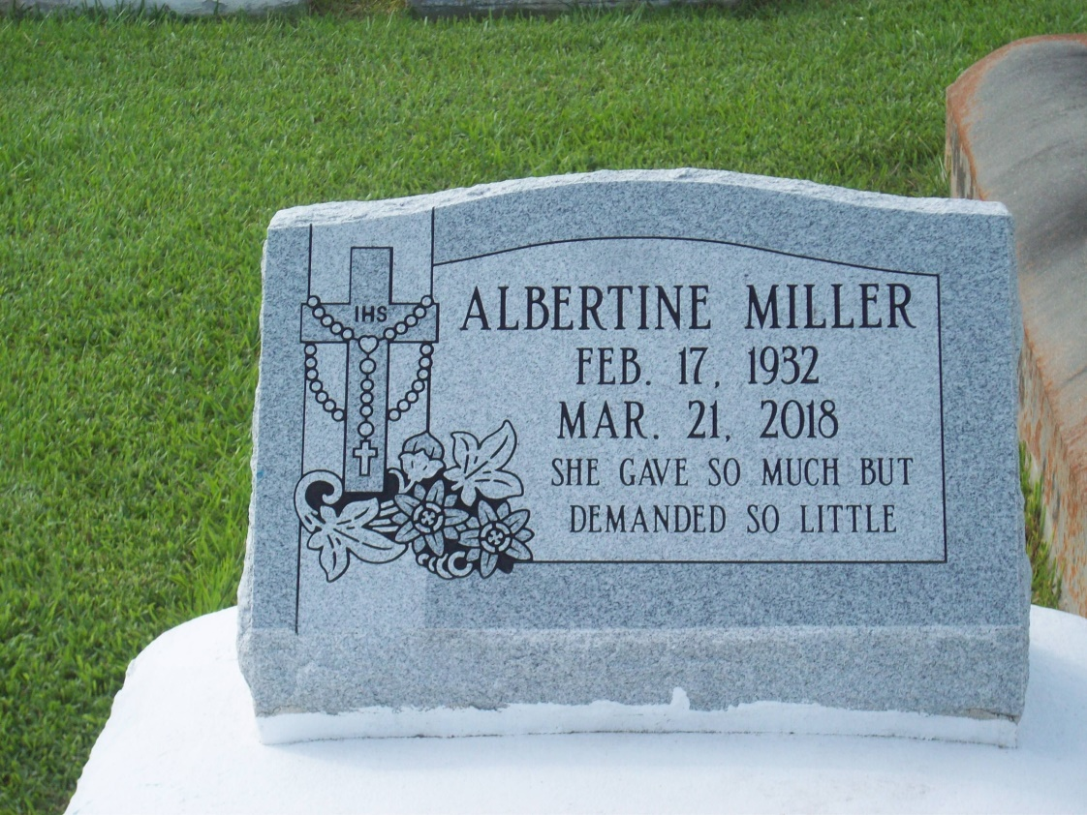

Photo by TMB

Albertine Louis Miller was born at St. Joseph Plantation on February 17, 1932 to Alberta Davis Louis and Marshall 'Tee Tout' Louis. On March 21, 2018 she went on to a better place. She is survived by her husband of sixty-three years, John Joseph Miller and her eight children, John David, Benedict Dean(Stella), Monica Juliana, Sabina Albertine, Lorus Lambert(Lisa), Jason Juan, Gilbert Horatio, and Hillary Lancelot(Adrienne). Also survived by a sister Rosemary Henry, and a host of grandchildren and great grandchildren. She was preceded in death by her parents Alberta and Marshall Louis, and siblings, Melvina Louis Mitchell, James Louis, Alvin Louis, Herman Louis, Fred Louis, Clarence Louis and Joseph Louis.

Unknown source