Laura (Becnel) Mitchell

January 16, 1920 – March 29, 1998

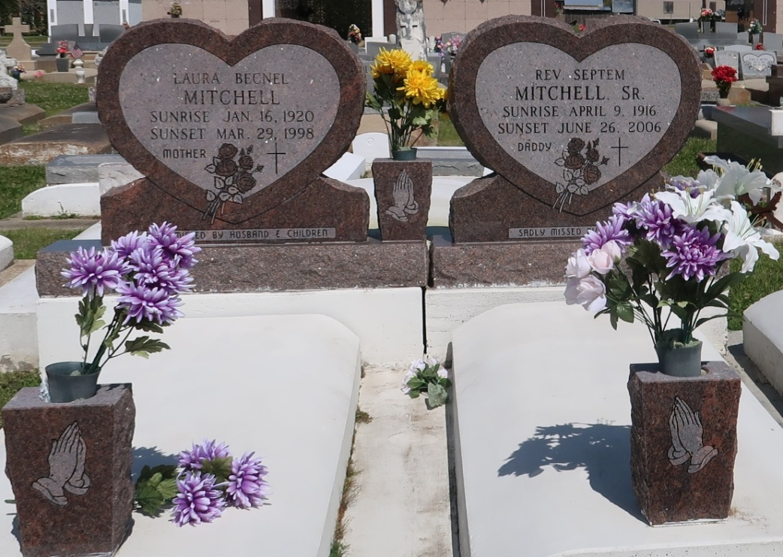

Religious services was at St. James Catholic Church in St. James for Laura Mitchell, 78, a native of White Castle and resident of St. James, who died at 7:25 p.m. March 29, 1998.  
 Visitation was at the church. Burial was at Our Lady of Peace Catholic Church Cemetery in Vacherie.  
 She was the wife of Septem Mitchell Sr. of St James; mother of Anita Lewis, Lorraine Smith and Charlene Hilliard, all of St James, Celestine Steib of Vacherie, Beulah Morris of Edgar, Jenny B. Wells of Avondale, Mary Lumar of Lucy, Septem Mitchell Jr. of Donaldsonville, Roosevelt and James Mitchell Sr. of St James, Ronald Mitchell of Edgar and Lester Mitchell Sr. of Reserve; sister of Albert Becnel of New Orleans. She is also survived by 31 grandchildren and 35 great-grandchildren.  
 She was preceded in death by her parents, Anita and Fabian Becnel; sons, David and Joseph Mitchell; sister, Annie B. Geason; and brother Neg Becnel.  
 She was a homemaker.

Unknown source