Rev. Septem Mitchell Sr.

April 9, 1916 – June 26, 2006

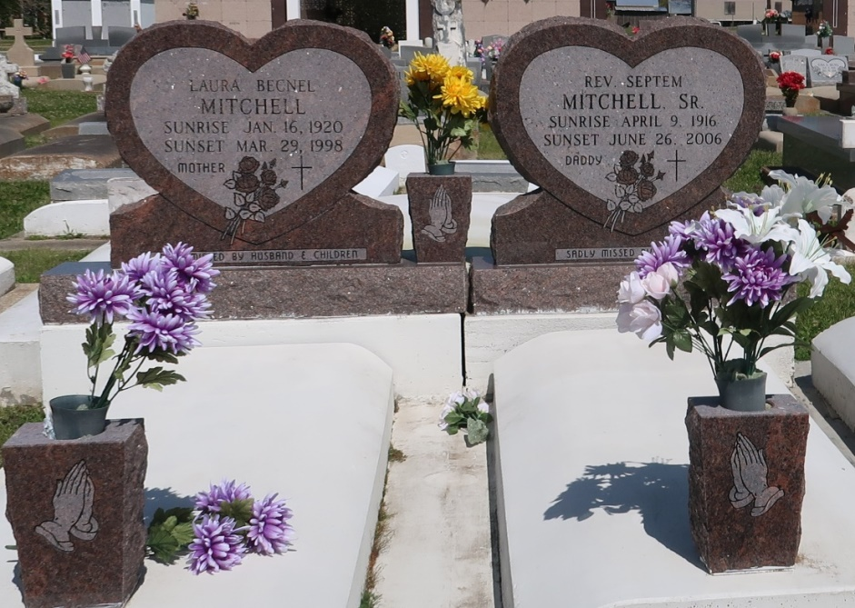

Mitchell Sr., the Rev. Septeme - A native and resident of St. James, he died Monday, June 26, 2006, at 1:35 p.m. at his home. He was 90. Visiting at Mount Calvary Baptist Church, St. James, on Saturday from 9:30 a.m. until religious service at 11 a.m., conducted by the Rev. Samuel Jones. Interment in Our Lady of Peace Cemetery in Vacherie. Survived by eight daughters and their spouses, Anita Lewis, Celestine and Ronald Steib, Evangelist Jenny and Bishop Ray Wells, Mary Etta and Joseph Lumar, Lorraine and Leonard Smith, Beulah and Lynn Morris and Charlene Hilliard and fiancé, Kevin Breaud; five sons and their spouses, Septeme Jr. and Betty Lou, Roosevelt, Ronald and Doreen, Lester and Terry, and James and Judy Mitchell; a surrogate daughter, Diane Hawkins; two sisters, Alice Joseph and Helen Sterling; two brothers, Wilson and Exodus Mitchell Jr. and his wife, the Rev. Shirley Mitchell; 36 grandchildren, 52 great-grandchildren; 11 great-great-grandchildren; and nieces, nephews, cousins, sisters and brothers-in-law, other relatives and friends. Preceded in death by his parents, Exodus Mitchell Sr. and Ella Geason Mitchell; wife, Laura Becnel Mitchell; two sisters, Izella and Annie Smith; brother, Henry Mitchell Sr.; grandson, Corey Mitchell; and two sisters-in-law, Ora and Tampy Mitchell. Brazier-Watson Funeral Home, Donaldsonville, is in charge of arrangements.

The Advocate, Baton Rouge, Louisiana

June 30, 2006