Roland Joseph Morton

August 20, 1954 – July 28, 2014

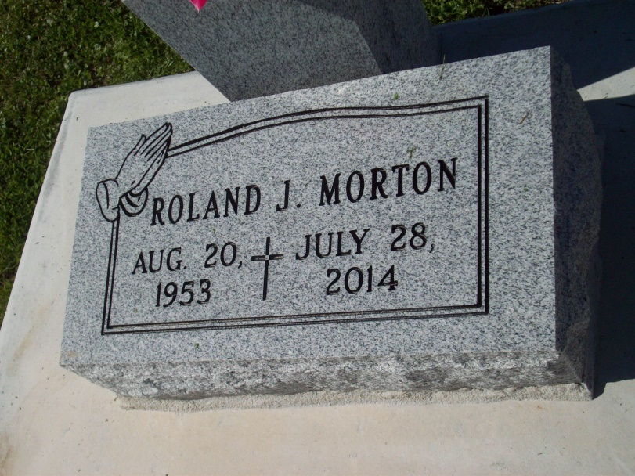

Photo by TMB

Roland "Pee Wee" Joseph Morton, passed away Monday, July 28, 2014, at the age of 60 years old. Son of the late Clarence and Emily Dumas Morton, Sr. Brother of Edna (Robert) Harry, Edmond (Joyce) Morton, Sr., Freddie (Shelia) Morton, Mary Ann (Rodney) Allen and the late Clarence (Mona) Morton, Jr. Also survived by a host of aunts, uncles, nieces, nephews, cousins, other relatives and friends.  
  
A Mass of Christian Burial will be held at Our Lady of Peace Catholic Church, 13281 Highway 644, Vacherie, La. on Saturday, August 2, 2014 at 11:00 a.m. Visitation will be from 9:00 a.m. until time of service. Father Michael Miceli will be officiating. Interment will be at Our Lady of Peace Cemetery, Vacherie, La. Funeral entrusted to The Baloney Funeral Home, LLC, 1905 W. Airline Highway, Laplace, La., 985-224-8460. Condolences can be expressed at [www.baloneyfuneralhome.com](http://www.baloneyfuneralhome.com).

Times-Picayune, The (New Orleans, LA) - Friday, August 1, 2014