Adrien Narcisse

November 4, 1888 – April 21, 1967

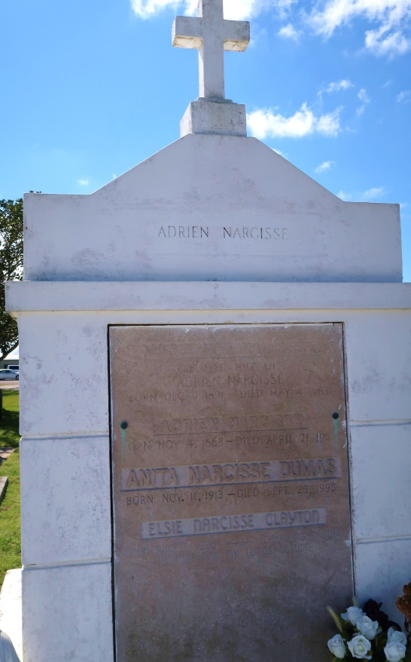 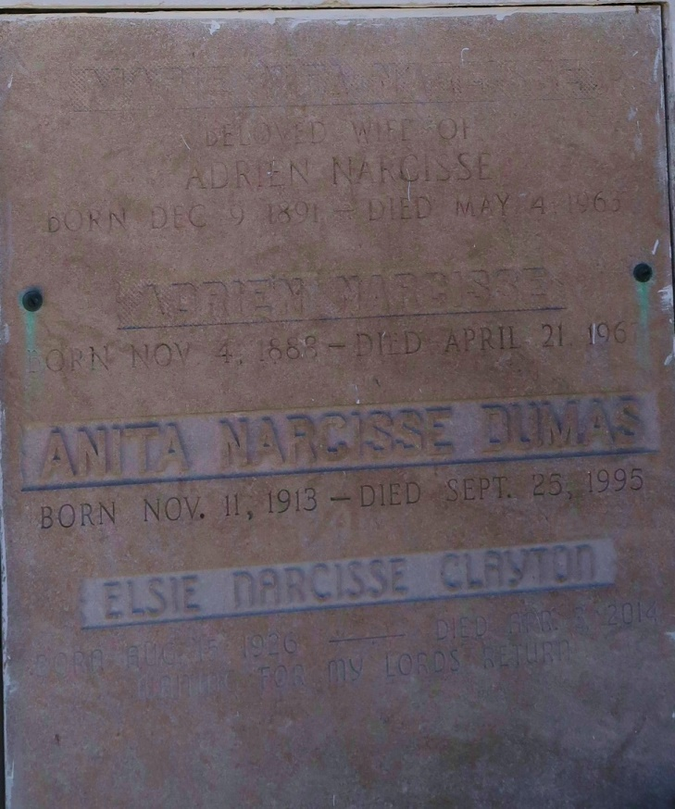

Died at 10:30 a.m. at his residence in Vacherie. A native and resident of Vacherie. he was 78. Wake services Sunday night at his residence, Route 1, Box 250, Vacherie. Religious services at Our Lady of Peace Catholic Church at 9 a.m. Monday under the direction of Father James Allain. Interment in church cemetery. He is survived by six sons, Andrew S., Joseph E, Lenden, Joe, Clifton, and Wilbert Narcisse, all of Vacherie; two daughters, Mrs. Elsie Narcisse, Lutcher, and Mrs. Anita Narcisse, Marrero. He was a member of Our Lady of Peace Catholic Church. Southside Funeral Home in charge of arrangements.

Advocate, The (Baton Rouge, LA)

Sunday, Apr 23, 1967, Page: 21  
Contributed by Jane Edson