Ernest Wine Narcisse

November 29, 1962 – May 9, 2005

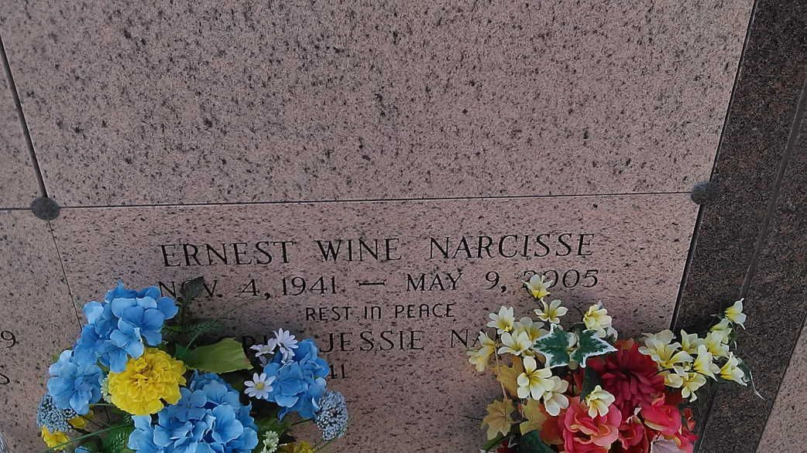

Photo by TMB

VACHERIE - Ernest "Wine" Narcisse, 63, a native and resident of Vacherie, died May 9.  
  
He was the husband of Elnoria Jessie Narcisse. He is survived by his mother Gladys Gros Narcisse, his children and spouses Bruce (Denise) and Barry (Roxie) Narcisse. He is also survived by two sisters, three brothers and five grandchildren.  
  
Services will be held today at 11 a.m. at Our Lady of Peace Catholic Church, Vacherie, with internment in the church cemetery. Williams and Southall Funeral Home, Nepoleonville is in charge of arrangements, visitation begins at 8 a.m.

L'Observateur (La Place, LA)

Wednesday, May 11, 2005

Contributed by Jane Edson