Gladys (Gros) Narcisse

June 5, 1918 – May 18, 2012

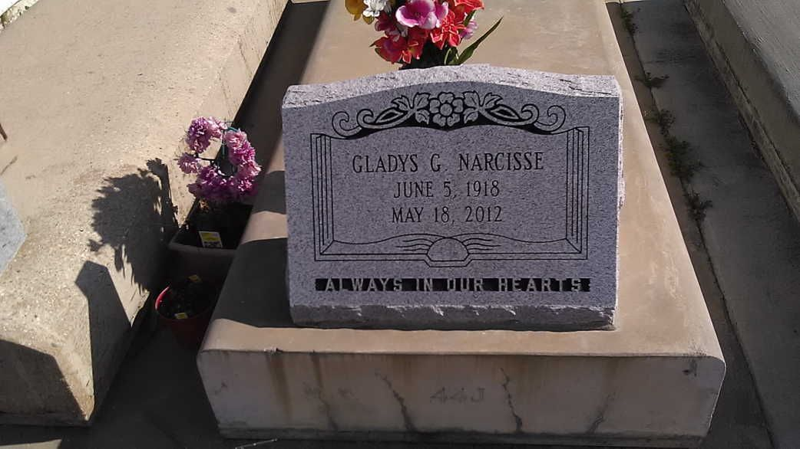

Photo by TMB

Gladys Gros Narcisse on Friday, May 18, 2012 at 6:05am in Thibodaux Regional Medical Center.

Wife of the late Joseph Narcisse. Daughter of the late Joseph N. Gros, Sr. and Olympe Dumas Gros. Mother of Mildred Armour (Norman), Mercedes Clarke (Frederic), Morrison (DeAudrey) and Paul (Doris) Narcisse all of Vacherie, La., James (Isabelle) Narcisse of Westwego, La. and the late Ernest Narcisse. Sister of Raymond Gros, Sr. (Imelda), Ledora Burrull, Regina and Alice Steib, Daisy Mitchell (Ridgely), Rose Boudoin (Teddy) and the late Francois Gros, Sr., Edmond Gros, Sr., Joseph N. Gros, Jr., Ollie Narcisse, Olivia Martin and Nazie Gros. Also survived by 12 grandchildren, 16 great grandchildren, 1 great great grandchild and a host of nieces, nephews, other relatives and friends.

Unknown source