Mable Marie (Tassin) Narcisse

September 13, 1946 – June 15, 2014

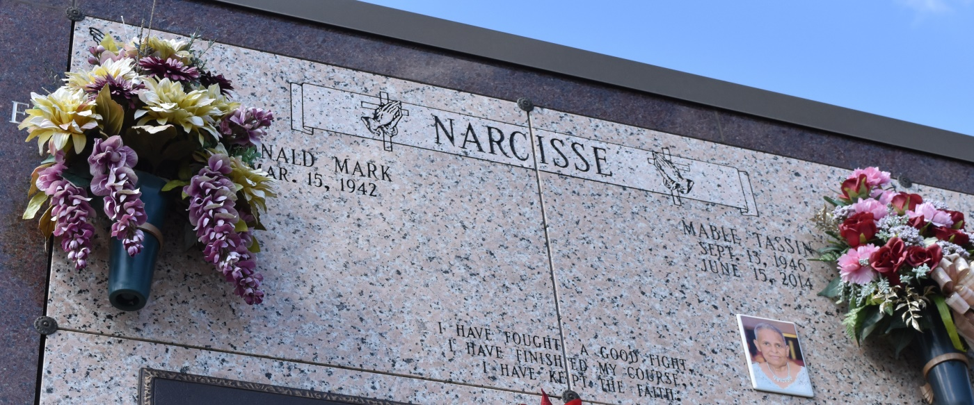

Mable Marie "Poola" Narcisse passed away Sunday, June 15, 2014 at the age of 67 years old. Daughter of the late Evelyn and Melvin Tassin Sr. Beloved wife of Ronald M. Narcisse. Mother of Troy (Karen) Narcisse, Nickever Narcisse, and Chaenika (Terryel) Benoit, Jr. Sister of Natalie (the late Lawrence) Braud, Brenda (Myron) Jones, Sr., Earl (Theresa) Tassin, Frances (the late Eunice) Dumas, Leroy (the late Orelia) Tassin, Melvin (the late Melinda) Tassin Jr., Cheryel (the late Fredrick) James Sr., Rosemary Jones, Diane Tassin, and the late Joseph (Josie) Tassin Sr. Also survived by a host of grandchildren, sister-in-laws, brother-in-laws, cousins, nieces, nephews, other relatives and friends. Funeral services will be held at Our Lady of Peace Catholic Church, 13281 Highway 644, Vacherie, La. on Saturday, June 21, 2014 for 11:00 a.m. Visitation will be from 8:00 a.m. until time of service. Father Michael Miceli will be officiating. Interment will be at Our Lady of Peace Catholic Church Cemetery, Vacherie, La. Funeral entrusted to The Baloney Funeral Home, LLC, 1905 W. Airline Highway, LaPlace, La., (985) 224-8460. Condolences can be expressed at [www.baloneyfuneralhome.com.](http://www.baloneyfuneralhome.com/)

The Advocate, Baton Rouge, Louisiana

Jun. 18 to Jun. 21, 2014