Raphael Narcisse

December 30, 1935 – April 9, 1997

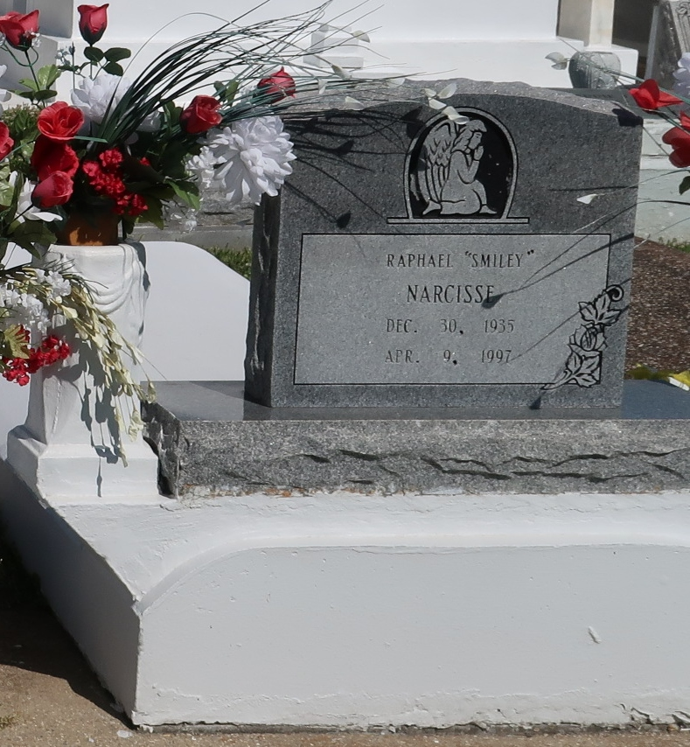

Raphael Narcisse, A Carpenter, Died Wednesday Of A Heart Attack At Thibodaux Regional Medical Center. He Was 61.  
 Mr. Narcisse Was A Lifelong Resident Of Vacherie. He Was A Member Of The Good Children's Benevolent Society.  
 Survivors Include Two Brothers, Frank And Felix Narcisse; And Four Sisters, Theresa Bartholomew, Earline Borne, Victoria Pierre And Augustine Saul.  
 A Mass Will Be Said Saturday At 11 A.M. At Our Lady Of Peace Catholic Church In Vacherie. Visitation Will Begin At 8 A.M. Burial Will Be In The Church Cemetery. D.W. Rhodes Funeral Home Is In Charge Of Arrangements.

Times-Picayune, New Orleans, La.

April 11, 1997