Montreal Denise (Scott) Noel

November 20, 1980 – June 16, 2017

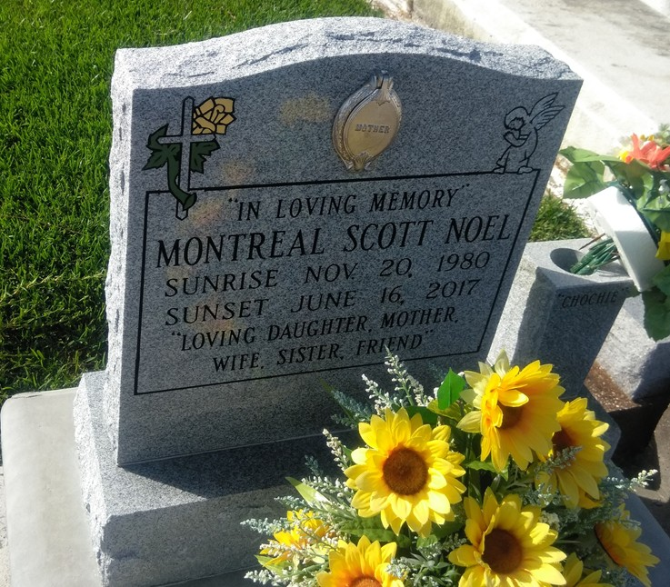

Photo by TMB

Montreal Denise Scott Noel, of Vacherie, LA. went home to be with the Lord on Friday June 16, 2017, age 36 years old. Beloved wife of Brandon Noel Sr.; Mother of Kayley, Laila and Brandon Jr.; Daughter of Clarence (Linda) Walters, and Angela (Andrew) Scott Dennis; Sister of Anthony, Chaunte, Alexis, Lachriosha (Shaffon), Manndarryl, Lendaz, Jorday (Alfred), and Tyesha. God daughter of Cynthia Melancon and Claude Baptiste. Daughter-in-law of Colleen Noel and Charles Nailor Sr. Survived by a host of aunts, uncles, nieces, nephews, one sister-in-law and three brothers-in-law other relatives and friends. She was preceded in death by her maternal grandparents Percy Sr. and Essie Scott and paternal grandparents Adeline and Clarence Walters Sr. Family and friends of the family, also employees of Dollar General Store Vacherie, LA. are invited to attend a mass of Christian burial on Saturday June 24,2017 at 11:00 am from Our Lady of Peace Catholic Church, 13281 La-644 Vacherie, LA. Visitation at the church after 9:00 am. Interment church cemetery. Final care entrusted to Treasures of Life Funeral Services 315 E. Airline Hwy. Gramercy, LA. 70052.

https://obits.nola.com/