Antoinette (Rodrigue) Olinde

December 14, 1978 – June 20, 2020

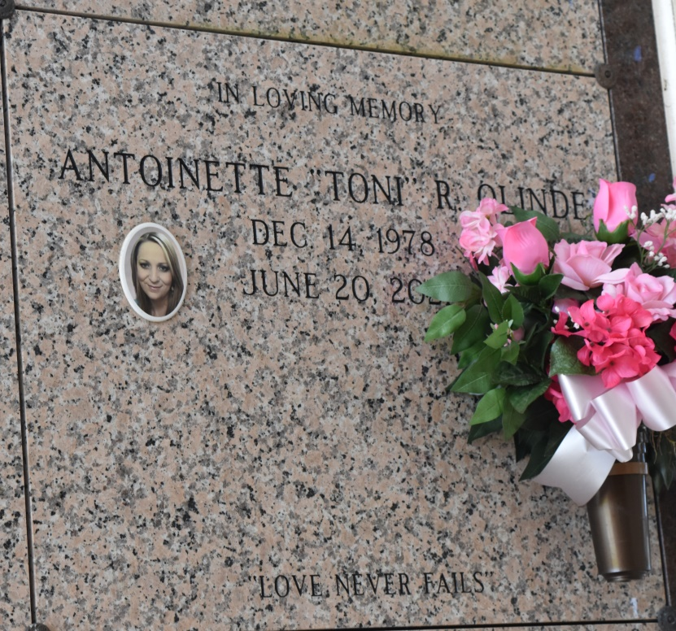

Antoinette "Toni" R. Olinde, 42, a native of Thibodaux, Louisiana and resident of Vacherie, Louisiana passed away on Sunday, June 20, 2021.  
 A visitation will be held in her honor on Thursday, June 24, 2021 at Our Lady of Peace Catholic Church, Vacherie, Louisiana from 9:00 am until the Funeral Service at 11:00 am. The burial will follow in Our Lady of Peace Cemetery, Vacherie, Louisiana.  
 She is survived by her loving husband, Kevin Olinde; daughter, Drue Polkey and her father Wayne Polkey; mother, Antoinette K. Rodrigue; godchildren, Fallon Terracina (Josh), and Mia Luke; nephews, Brandon Rodrigue (Katie), Shelby Lassere, Beau Rodrigue, Clay Tabor; nieces, Hailey Lassere, Madison and Mallory Terricina, Emma Rodrigue, Salena Tabor (Jordan); mother-in-law, Geraldine Olinde; brothers-in-law, Eric Falgoust and Lester Olinde; sister-in-law, Rebecca "Becky" Tabor Mazerac (Derald); godparents, Katherine R. Caire and Tommy Rodrigue.  
 She was preceded in death by her paternal grandparents, Maxime and Earline Rodrigue; maternal grandparents, Cyrille and Antoinette Kliebert; Pamphile and Marie Anna Webre; father, Leslie Rodrigue; brother, Cyril Rodrigue; and sister, Reasa Rodrigue Falgoust.  
 Toni was a devoted wife, mother, and daughter. She was an inspirational teacher for seven plus years and enjoyed gardening, music, dancing and spending time with her family.  
 Online condolences can be given at [www.thibodauxfuneralhome.com](http://www.thibodauxfuneralhome.com/)  
Thibodaux Funeral Home, Inc. is in charge of arrangements.

Houma Today, Terrebonne Parish, Louisiana

Jun. 22 to Jun. 23, 2021