Sidney V. Osborne Sr.

January 9, 1910 – October 4, 1983

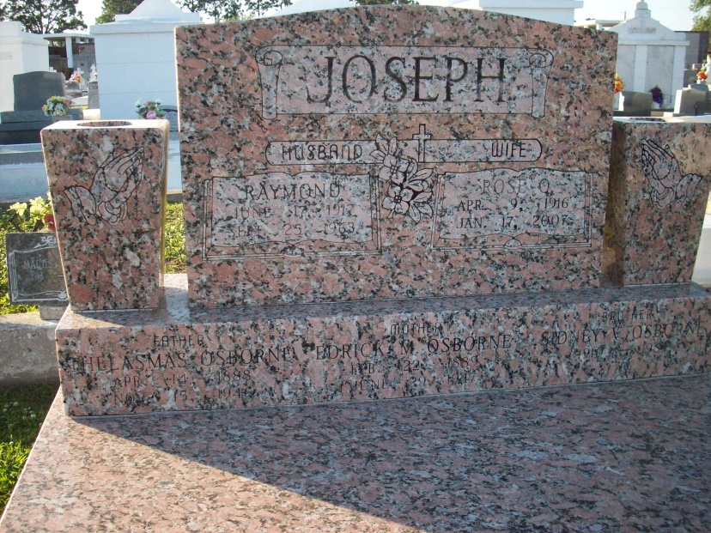 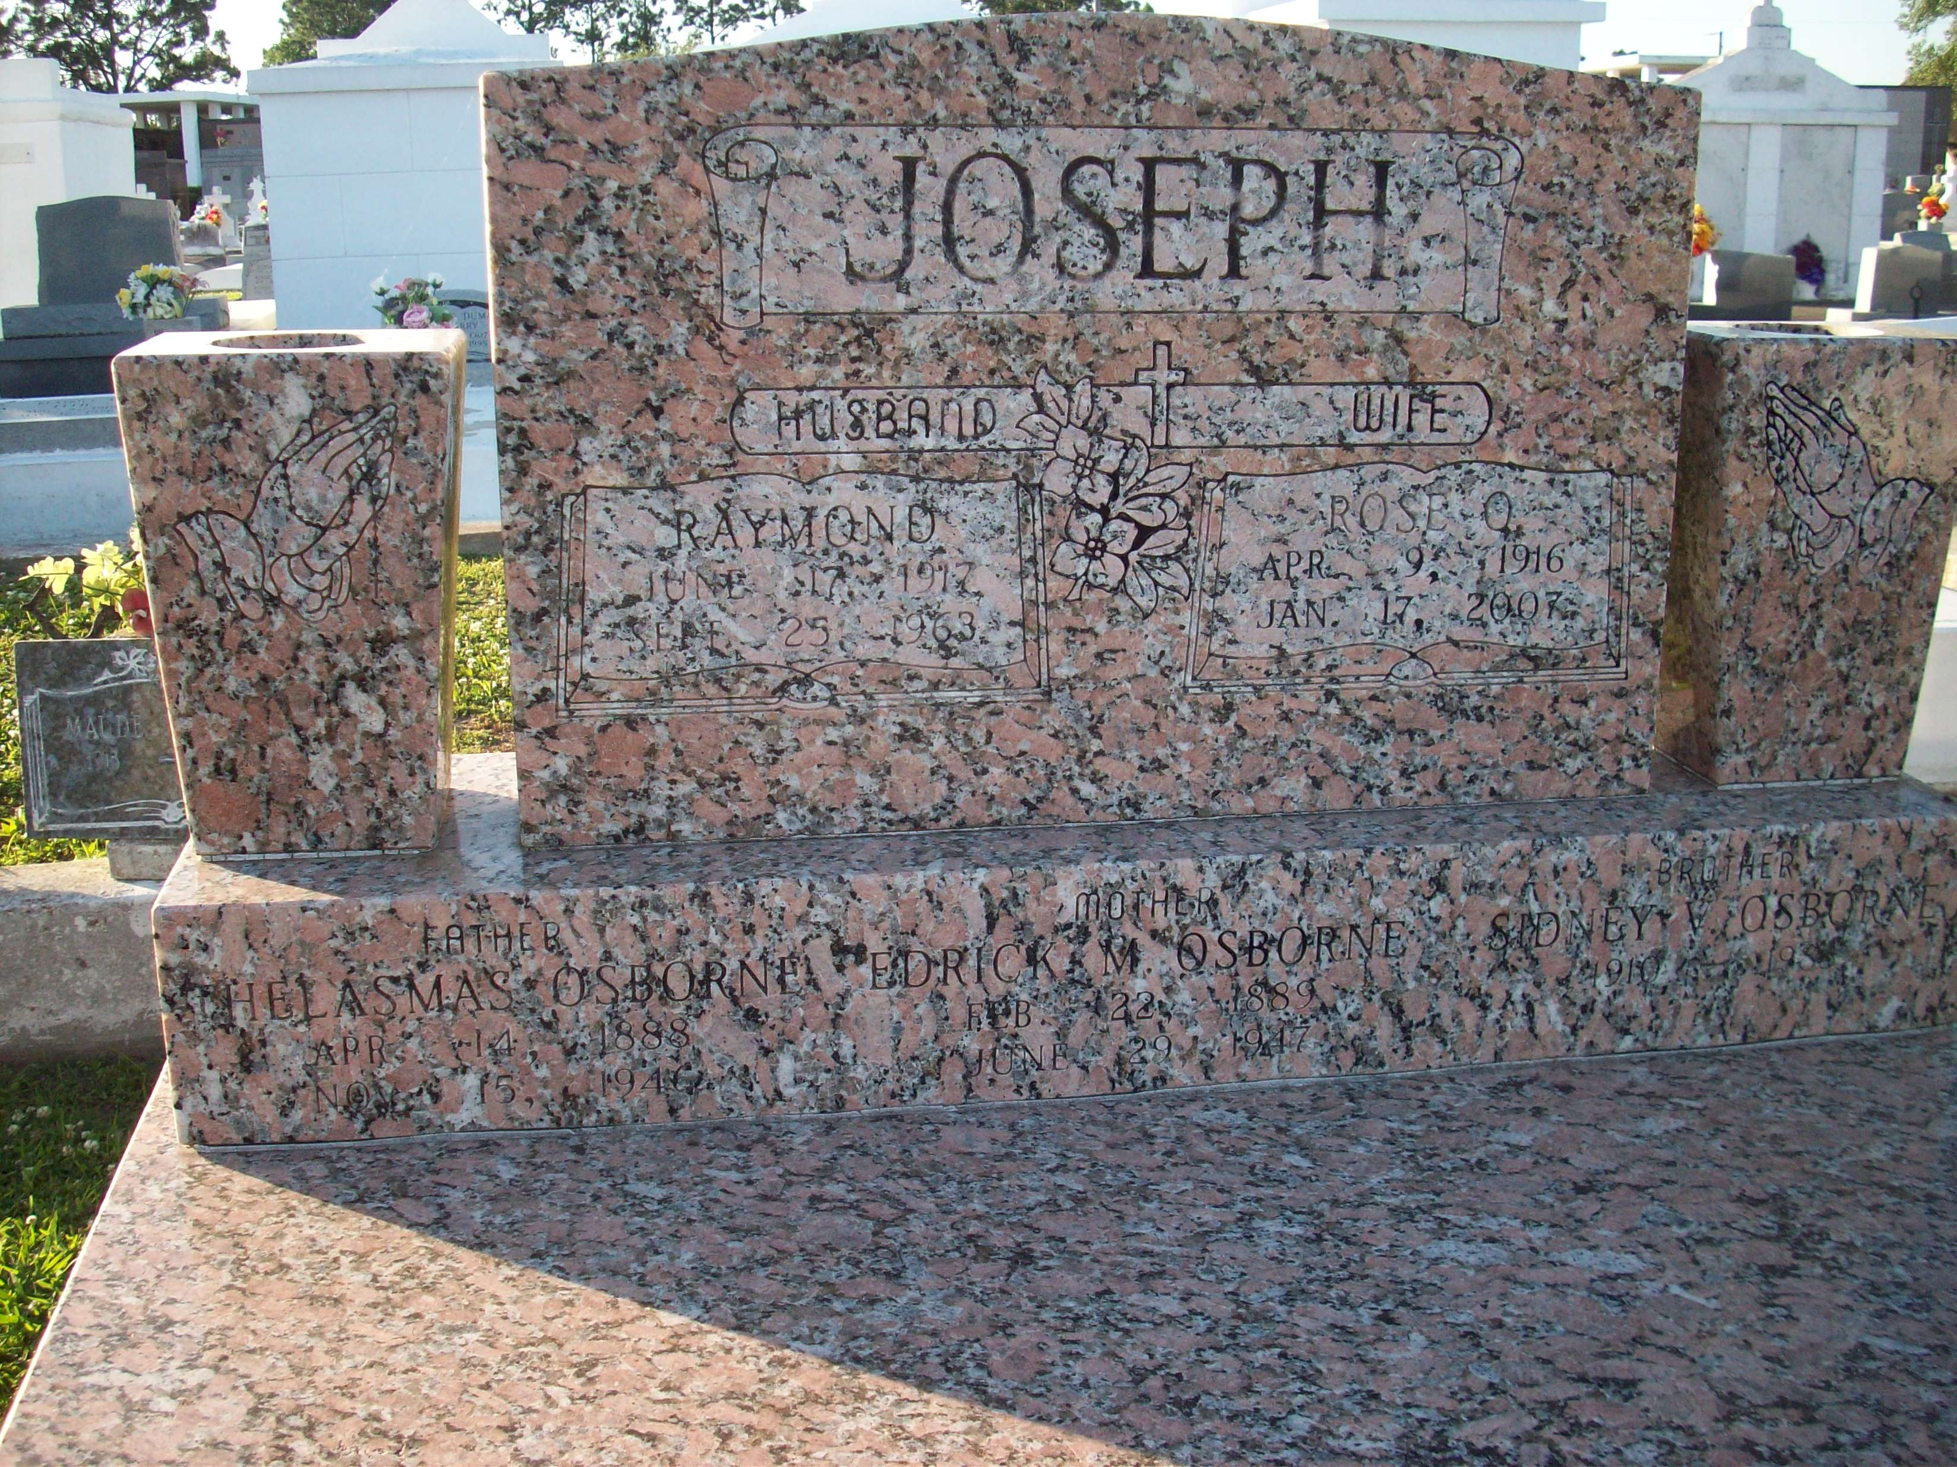

Photo by TMB

Sidney V. Osborne burial rites today

Funeral services for Sidney V. Osborne of Marrero were held at 7:30 p.m. Friday at St. Joseph the Worker Catholic Church, Marrero. Interment will be in Our Lady of Peace Cemetery, Vacherie, at 9 a.m. Saturday.

Mr. Osborne, 73, died Tuesday in Marrero.

He was born in Vacherie, and was a longtime resident of Marrero.

Survivors include five daughters, Susan Nicholas, Diann Lewis, Agnes Wade, Gwendolyn Martin and Iris Breaux; a son, Sidney V. Osborne Jr.; six sisters, Girlie Jasmin, Aldonia Adams, Rose Joseph, Angelina Whaley, Marie Bastian and Mrs. Maurice Osborne; 17 grandchildren and seven great-grandchildren.

Unknown newspaper clipping