Amelius Joseph Oubre, Jr.

March 19, 1919 – August 24, 2006

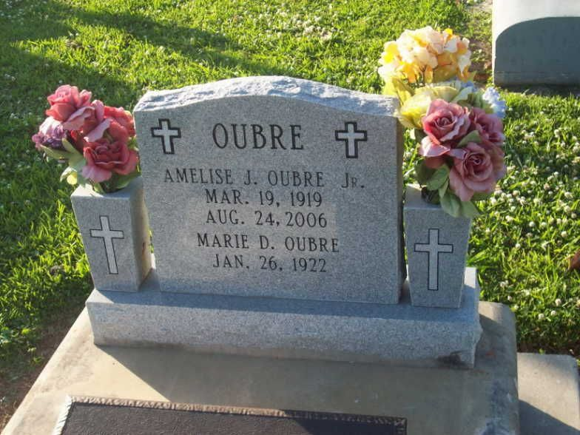

Photo by TMB

Amelius Joseph Oubre Jr. was a native and resident of Vacherie, he died Thursday, Aug. 24, 2006, at Thibodaux Regional Medical Center. He was 87. Survived by his wife, Marie Dumas Oubre; two daughters and sons-in-law, Joelle and Felix Narcisse of Vacherie and Amelia and Alvin Jefferson of Charlotte, N.C.; six grandchildren, Adela, Erin, Hilary, Ashley, Heather and Ron; great-grandson, Blake; brother, Ursin Oubre; and a host of other relatives and friends. Preceded in death by parents, Katherine and Amelise Oubre Sr.; four brothers, Joseph Eddie Sr., Joseph Olean, John Oscar and Freddie Oubre Sr.; four sisters, Norine Domino, Josephine Scott, Aimee Narcisse and Katherine Oubre. He was a U.S. Army veteran, member of Father Van Baast Assembly 23 Fourth Degree Knights of Peter Claver, Our Lady of Peace Third Degree Knights of Peter Claver, Good Children Benevolent Society and American Legion Post 565.

Unknown source

\*\*\*\*\*

Oubre Jr., Amelise Joseph

A native and resident of Vacherie, he died Thursday, Aug. 24, 2006, at Thibodaux Regional Medical Center. He was 87. Visiting at Our Lady of Peace Catholic Church in Vacherie on Tuesday from 8 a.m. until Mass of Christian Burial at 11 a.m., conducted by the Rev. Michael Miceli. Burial in the church cemetery.

Survived by his wife, Marie Dumas Oubre; two daughters and sons-in-law, Joelle and Felix Narcisse of Vacherie and Amelia and Alvin Jefferson of Charlotte, N.C.; six grandchildren, Adela, Erin, Hilary, Ashley, Heather and Ron; great-grandson, Blake; brother, Ursin Oubre; and a host of other relatives and friends. Preceded in death by parents, Katherine and Amelise Oubre Sr.; four brothers, Joseph Eddie Sr., Joseph Olean, John Oscar and Freddie Oubre Sr.; four sisters, Norine Domino, Josephine Scott, Aimee Narcisse and Katherine Oubre.

He was a U.S. Army veteran, member of Father Van Baast Assembly 23 Fourth Degree Knights of Peter Claver, Our Lady of Peace Third Degree Knights of Peter Claver, Good Children Benevolent Society and American Legion Post 565. Arrangements by Williams & Southall Funeral Home, Napoleonville, (985) 369-7231.

Advocate, The (Baton Rouge, LA)

Monday, August 28, 2006

Contributed by Jane Edson