Eddie Joseph Oubre

November 3, 1959 – December 31, 2010

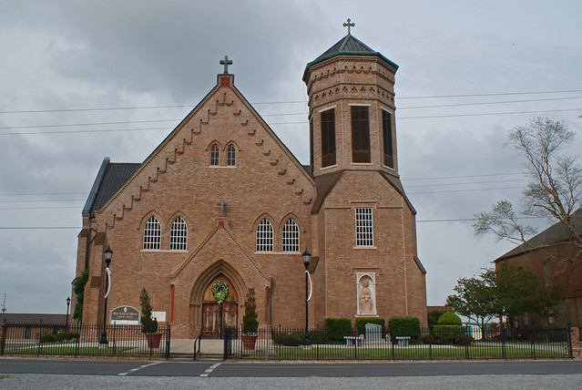

Eddie Joseph "Voup" Oubre Jr., 51, a native and resident of Vacherie, passed away Friday, Dec. 31, 2010. He is survived by his wife of 17 years, Tammy Stein Oubre; daughter, Hayley Oubre; son, Jarred Oubre; mother, Therese Gravois Oubre; and sister, Catherine O. Hymel, all of Vacherie.

He was preceded in death by his father, Eddie J. Oubre Sr.; brothers, Wade Oubre, Lowell Oubre and Timothy Oubre; and sisters, Annette O. Stein and Ellen O. Mula.

Visitation at Our Lady of Peace Catholic Church in Vacherie on Monday, Jan. 3, from 8 a.m. until Mass of Christian Burial at 11 a.m. Entombment in the church mausoleum. Condolences can be made at www.oursodonaldsonville.com.

Published in The Advocate, Baton Rouge, LA, on January 2, 2011