Elton Joseph Oubre

February 20, 1938 – December 12, 2012

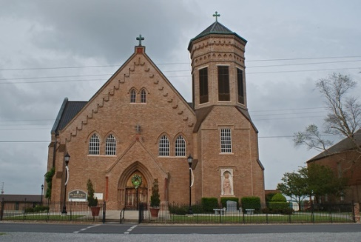

Elton J. Oubre, 74, a historian, genealogist and author was born on February 20, 1938 and passed away on December 12, 2012. He was a native of Vacherie, and a resident of Thibodaux.  
 Visitation will be from 5 to 9 p.m. Sunday at Thibodaux Funeral Home in Thibodaux. Visitation will continue from 9 a.m. until funeral time Monday at Our Lady of Peace Catholic Church in Vacherie. Mass of Christian Burial will be at 1 p.m. Monday at the church, with burial in the church cemetery.  
 He is survived by his wife. Sara Canepa Oubre; daughters, Robyn Cooley and husband, Dale, Jennifer Baudoin and husband, Chad; brothers, Leo Oubre and wife, Geraldine, Raymond Oubre and wife, Evelyn, Daniel Oubre and wife, Lona; sisters, Bertha Rome and husband, Leroy, Carol Delatte and husband, Barry and Sally Authement; five grandchildren, Andrew Cooley, Joshua Cooley, Cecilia Baudoin, Leah Baudoin and Zoe Baudoin; and numerous nieces and nephews.  
 He was preceded in death by his parents, Pierre Oubre and Beulah Oubre Oubre; brother, Pierre Oubre Jr.; sisters, Dixie Oubre and Janice Oubre; paternal grandparents, Emile and Therese Kliebert Oubre; and maternal grandparents, Sylvest and Zeoline Ockman Oubre.  
 In lieu of flowers, donations can be sent to the E.D. White Band and Music Program, 555 Cardinal Drive, Thibodaux, LA, 70301. Thibodaux Funeral Home in Thibodaux is in charge of arrangements.

Published in Houma Today & The Daily Comet from Dec. 14 to Dec. 15, 2012

Author of ***Vacherie, St. James Parish, Louisiana: History And Genealogy***