Michael Amelise Oubre

December 13, 1950 – July 16, 2005

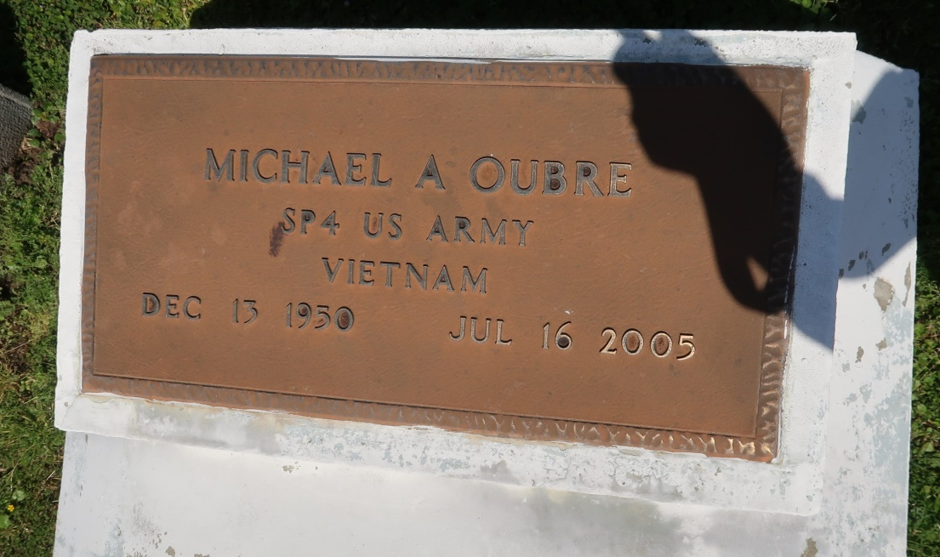

Michael Amelise Oubre on Saturday, July 16, 2005 died at his residence in Vacherie, LA. after a courageous battle with lung cancer. Son of the late Freddie, Sr. and Pauline Philip Oubre; husband of Ethel Marie Oubre; Father of Kimatakaya Joseph, brother of Katherine O. Pedescleaux, Freddie, Jr. and Raymond Oubre; grandfather of Lyric Miller; also survived by 4 stepchildren, 9 step grandchildren, 1 step grandchild and a host of aunts, uncles, nieces, nephews, other relatives and friends. He was 54 and a native of Vacherie, LA. Family and friends are invited to attend the Mass of Christian Burial at Our Lady of Peace Catholic Church, Vacherie, LA. on Saturday, July 23, 2005 beginning at 11:00AM conducted by Father Michael Miceli. Interment in the church cemetery. Visitation will begin at 8:30AM and recitation of the rosary at 9:30AM. He served in the United States Army for 2 years and was a former welder. WILLIAMS & SOUTHALL FUNERAL HOME, NAPOLEONVILLE, LA. in charge of arrangements.

The Times-Picayune, New Orleans, Louisiana

July 22, 2005