Pauline (Philip) Oubre

September 4, 1925 – July 14, 2001

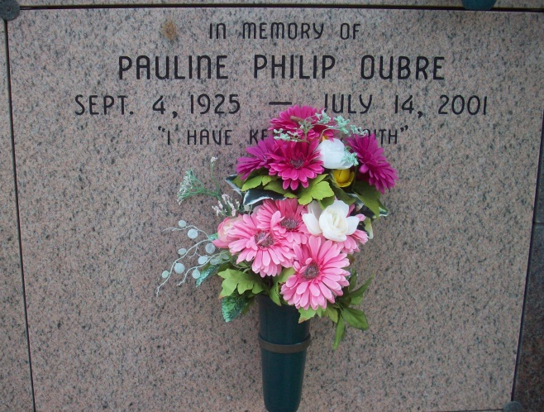

Photo by TMB

Pauline Philip Oubre, 75

A loving wife and mother, she died Saturday, July 14, 2001, at Thibodaux Regional Medical Center. She was 75 and a lifelong resident of Vacherie.

Visiting at Our Lady of Peace Catholic Church, Vach-erie, from 8 a.m. to 10:45 a.m. Wednesday. Mass of Christ-ian Burial at the church at 11 a.m. Wednesday, conducted by the Rev. Henry Gautreau. Entombment in church mausoleum.

Survived by a daughter, Catherine Pedescleaux; three sons, Freddie Jr., Raymond and Michael Oubre; five sisters, Doretha Keller, Eva Landreaux, Theresa Weber, Fannie Philip and Catherine Frances; a brother, Joseph Philip; and a host of grandchildren, sisters-in-law, brothers-in-law, daughters-in-law, a son-in-law, nieces, nephews, other relatives and friends.

Preceded in death by her husband, Freddie P. Oubre; parents, Stanislase and Natalie Philip; and two brothers, Walter and John Philip.

She was a member of Our Lady of Peace Court 161 Knights of Peter Claver Ladies Auxiliary and Good Children Benevolent Society. Williams & Southall Funeral Home, Napoleonville, in charge of arrangements.

Advocate, The (Baton Rouge, LA) - Tuesday, July 17, 2001