Therese Marie (Gravois) Oubre

November 4, 1888 – April 21, 1967

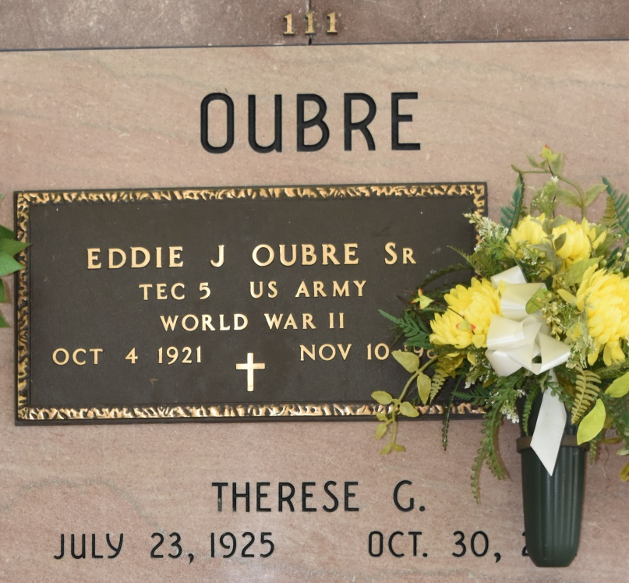

Therese Marie Gravois Oubre, 86, passed away on October 30, 2011. She was a native and resident of Vacherie. Therese was a committed Adorer for 19 years at Our Lady of Peace Catholic Church Adoration Chapel. She is survived by her daughter Catherine O. Hymel and husband Raymond "Pete"; 16 grandchildren; and 15 great grandchildren. Preceded in death by her husband Eddie J. Oubre Sr.; six children Wade Oubre, Lowell Oubre, Annette O. Stein, Ellen O. Mula, Timothy Oubre, and Eddie "Voup" Oubre, Jr.; parents Ernest Gravois and Berthe Rodrigue Gravois; six sisters Aline Rodrigue, Elise Becnel, Marie Falgoust, Angele Steib, Henrietta Gravois, and Marie Claire Hirsch; six brothers Antoine "Tony" Gravois, Louis Gravois, Joseph Gravois, Leonard Gravois, Jean Paul Gravois, and Augustin "Gus" Gravois. Visitation will be held on Thursday, November 3, 2011 at Our Lady of Peace Catholic Church in Vacherie from 8:00 a.m. until Mass of Christian Burial at 11:00 a.m. Interment will follow in church mausoleum.

Unknown source