Anne (Brazan) Peterson

March 28, 1929 – October 7, 2019

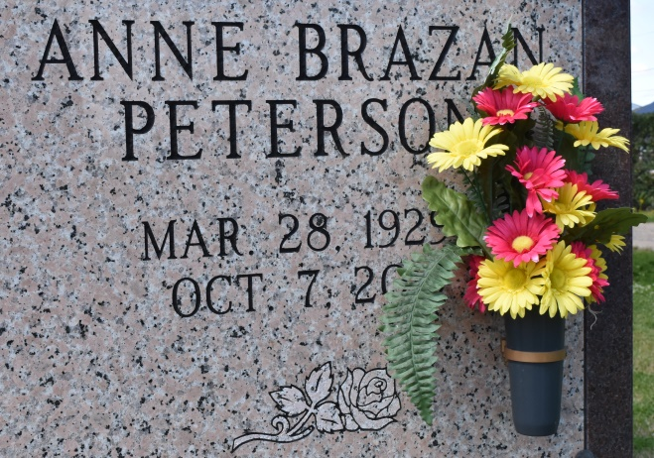

Anne Brazan Peterson, 90, a native of Vacherie, Louisiana and resident of Baton Rouge, Louisiana passed away on Monday, October 7, 2019. A visitation will be held in her honor on Friday, October 11, 2019 at Our Lady of Peace Catholic Church, Vacherie, Louisiana from 8:30 am until the Mass of Christian Burial at 11:00 am with the Rosary at 9:30 am. The burial will follow in Our Lady of Peace Cemetery, Vacherie, Louisiana. She is survived by her siblings, Essie Marie Brazan, Patricia Brazan Bellanger, and Cheryl Brazan Hubbell; sister-in-law, Peggy H. Brazan; and numerous nieces and nephews. She was preceded in death by her husband, Charles F. Peterson; parents, Louis F. Brazan Jr. and Olinie Lasserre Brazan; and siblings, Lydia Brazan Dufrene, Rose Mary Brazan Becnel, Charles Anthony Brazan, and Gaspard "Gene" James Brazan. Anne worked for South Central Bell for many years and was a member of the Telephone Pioneers. She was also a parishioner of St. George Catholic Church in Baton Rouge. Online condolences can be given at [www.thibodauxfuneralhome.com](http://www.thibodauxfuneralhome.com/); Thibodaux Funeral Home, Inc. is in charge of arrangements.

The Advocate, Baton Rouge, Louisiana

Oct. 9 to Oct. 11, 2019