Joseph Philip

November 9, 1900 – December 24, 2001

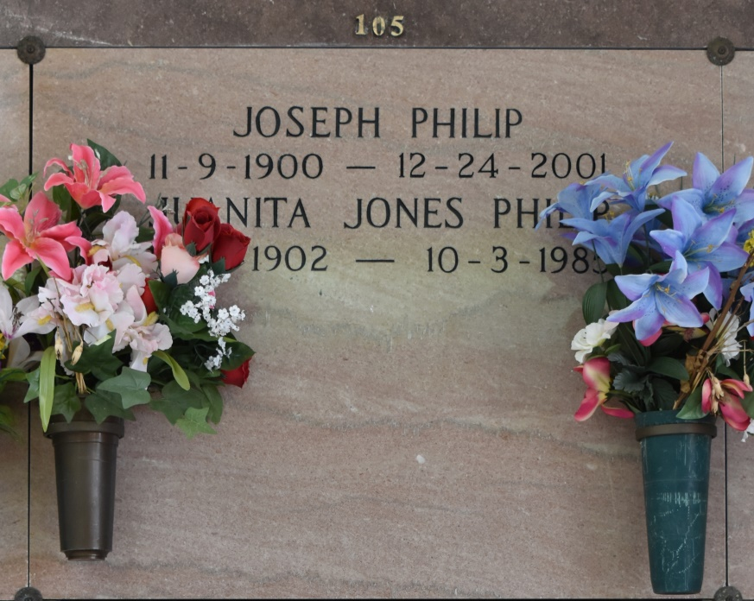

A native and resident of Vacherie, he died Monday, Dec. 24, 2001, at Riverlands Health Care Center in Lutcher. He was 101 years old. Visiting at Our Lady of Peace Catholic Church, Vacherie, from 9 a.m. until Mass of Christian Burial at 11 a.m. Saturday. Interment in the church cemetery. Survived by a host of nieces, nephews, other relatives and friends, including Melba Oubre Collins of Edgard. Preceded in death by his wife, Juanita Jones Philip; parents; three sisters and three brothers. Williams & Southall Funeral Home, Thibodaux, in charge of arrangements.

Advocate, The (Baton Rouge, LA)

Friday, December 28, 2001  
Contributed by Jane Edson