Tevin Joseph Philip

May 12, 1993 – September 10, 2019

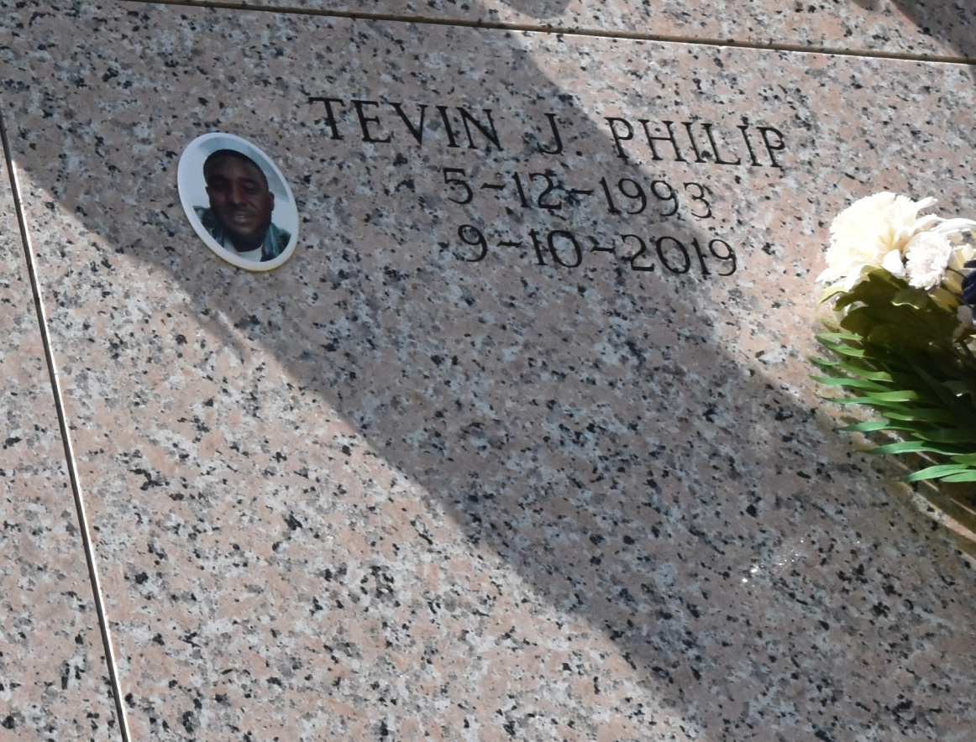

Tevin Joseph Philip of Reserve, LA unexpectedly passed away on September 10, 2019 at Ochsner River Parish in LaPlace, LA.

He was born in Houma, LA to Ella C. Philip and Freddie Albert Jr. on May 12, 1993. He was a 2011 graduate from Lutcher High School.

Tevin is survived by his loving mother, Ella C. Philip; his son Kash T. Philip; grandmother Cora Lee Barney, Godfather Frederick Scott, siblings Fredrina Wallace, Dontel Hill, Freddie Albert III, and Ashanti Albert. He is also survived by aunts Lana Philip, Veronica Zenon, Phyllis Clay, and Marie Growe. He will always be affectionately remembered by cousins Joy Armant - Eugene (Nolan), Tynia, Raneisha, Tyran, and Tyler Vinning, Jenee Miller (Clinton), Justin Vinning (Brionne), and Mychelle Mumphrey; also a host of other relatives and friends.

Tevin is preceded in death by his father Freddie Albert Jr.; grandparents Joseph E. Philip, Dory R. Philip, and Freddie Albert Sr.; great grandparents Marie O. Roussell, Irma and Junes Gains, and Ernest and Velma Albert. He is also preceded in death by his Godmother Hazel A. Scott; uncles Lawrence P. Armant and Sidell Armant; and cousins RaShad Williams, Benjamin Armant, and Starr January.

A Mass of Christian burial will be held at Our Lady of Peace, 13281 LA-644, Vacherie, LA 70090 on Saturday, September 21, 2019 at 11 a.m. Visitation will begin at 9 a.m. followed by the Rosary at 9:30 a.m. Entombment at Our Lady of Peace Catholic Church Cemetery. Final care has been entrusted to Treasures of Life Funeral Services, 315 E. Airline Hwy Gramercy, LA 70052.

Treasures of Life Funeral Services

Gramercy, Louisiana