Loretta Jane (Veillon) Poirrier

March 23, 1931 – March 8, 2021

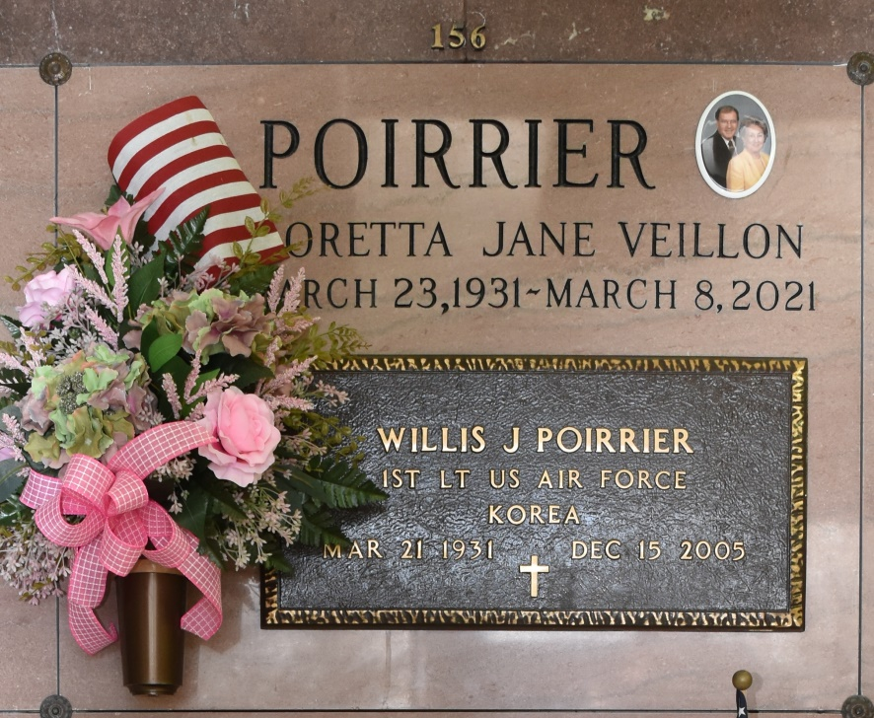

Loretta Jane Veillon Poirrier, 89, passed away at 6:45 AM on Monday, March 8, 2021 at Inspired Living in Kenner, LA. A native of Mamou, LA and a resident of Vacherie, LA. Born on March 23, 1931. She graduated from Soule College in New Orleans with a Associate Degree of Business.

She is survived by her children, Jean Willis Poirrier II and wife Lise of Vacherie, Cindy Poirrier Job and husband Lyndsay of Orange Beach, AL, Pam Poirrier Buchtel-Hussey and husband Michael of Metairie and Tesa Poirrier Becnel and husband Charles of Metairie; grandchildren, Cammie Poirrier Delaune and husband Drew, Jean Poirrier III and wife Karlie, Andree Eddleman and husband Lane, Lindsey Buchtel Joseph and husband George, Caroline Buchtel, Samantha Hussey Lamanna and husband Simone, Stence and Tanzy Jean Becnel; great-grandchildren, Tate, Sarah, and Ella Delaune, Camille and Thomas Eddleman, Jake Willis, Jessie Poirrier and Nadia Joseph; brothers, Nolan Veillon and wife Ramona and Winston Veillon and wife Carolyn; sister, Winnie Veillon Robert.

She is preceded in death by her husband, Willis Joseph Poirrier; parents, Tanzy and Lovella Israel Veillon; brother-in-law, Bob Robert.

A private memorial service will be held in her honor at a later date. Rose Lynn Funeral Services has been entrusted with handling her arrangements.

Rose Lynn Funeral Home, Lutcher, LA