Willis Joseph Poirrier

March 21, 1931 – December 15, 2005

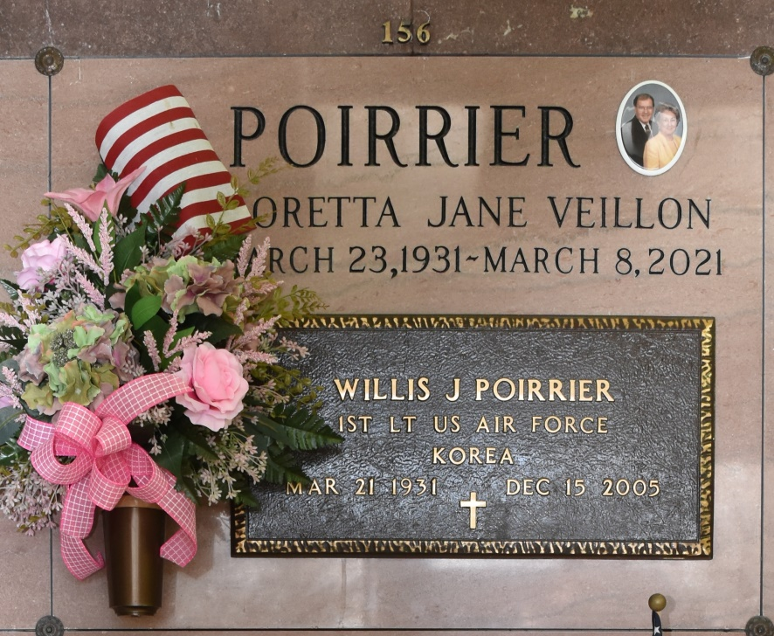

Willis Joseph Poirrier, age 74, passed away at 11:37 p.m. on Thursday, December 15, 2005 at Ochsner Hospital in New Orleans, LA.

A native and resident of Vacherie, LA. Born March 21, 1931; he was the President and Manager of Vacherie Loans for 34 years. He proudly served our country as an officer in the United States Air Force during the Korean War. He graduated from Tulane University with a Bachelor of Science Degree.

Survived by his wife, Loretta Jane Veillon Poirrier of Mamou, La.; four children: Jean Willis Poirrier II and wife Lise of Vacherie LA, Cindy Poirrier Job and husband Lyndsay of Metairie, LA, Pam Poirrier Buchtel-Hussey and husband Michael of Metairie, LA and Tesa Poirrier Becnel and husband Charles of Metairie, LA; grandchildren: Cammie Poirrier Delaune, Jean Poirrier III, Andree Poirrier, Lindsey and Caroline Buchtel, Samantha Hussey, Stence and Tanzy Jean Becnel; great-grandchildren, Tate and Sarah Delaune.

Preceded in death by his parents, Jean Willis Poirrier and Freida Falgoust Poirrier. Mr. Poirrier was a member of the Knights of Columbus, Lutcher & Gramercy Lions Club, The American Legion, and The Louisiana Finance Association. He served as director of St. James Bank and Regions Bank for 30 years. Willis enjoyed yard work and keeping his cars clean.

Visitation is on Monday, December 19, 2005 at 8:00 - 11:00 a.m. at St. Philip Catholic Church, 1175 Hwy. 18, Vacherie, LA. Followed by a Mass of Christian Burial at 11:00 a.m. in St. Phillip Catholic Church, celebrated by Father Michael Galea. Entombment following Mass at Our Lady of Peace Cemetery, Vacherie, LA. In lieu of flowers, please make donations to the American Heart Association. Rose Lynn Funeral Services, Lutcher, LA (225) 869-0000 is in charge of arrangements.

The Times-Picayune, New Orleans, LA

December 17-18, 2005