Anita (Dulle) Rennhoff
May 29, 1938 – May 18, 2021

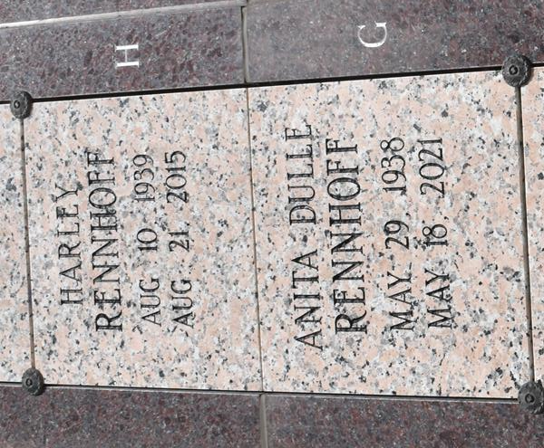

Anita Dulle Rennhoff, a longtime resident of Baton Rouge, died peacefully on Tuesday, May 18, 2021 at the age of 82. A native of Belleville, Illinois, she was preceded in death by her husband, Harley Rennhoff, parents Joseph and Agnes Dulle, and brothers David Dulle and Jim Dulle.
Anita was a loving and devoted wife, mother, grandmother, and sister and will be missed dearly by all those who knew and loved her. She is survived by her children, Julie Rennhoff Rivet, Michael Rennhoff and wife Elizabeth, and Steven Rennhoff and wife, Stacy; her six granddaughters, Rachel Rivet Perez and husband Dr. William Perez, Chelsea Rennhoff Whiting and husband Giles Whiting, and Ally, Amelia, Lily, and Grace Rennhoff. She is also survived by her brother, Stanley Dulle and wife Judy, Maurice Dulle and wife Karen, sister Jean Dulle Biekert, and Mary Jo Dulle Kramer and husband Brian Kramer.
A private family service will be held by the immediate family. In lieu of flower, donations can be made to a charity of choice. Special thanks to The Crossing at Clarity Hospice of Baton Rouge for their compassionate care.

Advocate, The (Baton Rouge, LA)
Saturday, May 22, 2021

