Harley Rennhoff
August 10, 1939 – August 21, 2015

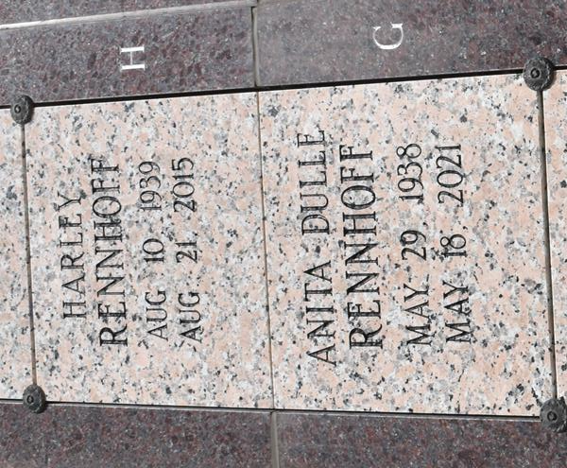

Harley Rennhoff passed away Friday, August 21, 2015 at the age of 76. He was a loving and devoted husband, father, grandfather and brother and will be missed dearly by all those who knew and loved him. Harley was born in Belleville, Illinois and enjoyed careers in banking, business, and writing.
He is survived by his wife of 56 years, Anita Dulle Rennhoff. He is also survived by his children, Julie Rennhoff Rivet, Michael Rennhoff and wife, Liz, and Steven Rennhoff and wife, Stacy; his six granddaughters, Rachel Rivet, Chelsea Rennhoff and husband Giles Whiting, and Ally, Amelia, Lily and Grace Rennhoff; his brother, David Rennhoff and wife Barbara of Pittsburgh, Pennsylvania and sister Carol Rennhoff Kirby and husband Tom of Belleville, Illinois. Also survived by numerous nieces and nephews. He is preceded in death by his parents, Ewald and Aurelia Sauzek Rennhoff.
A private family service will be held by immediate family. In lieu of flowers, donations may be made to your charity of choice. Special thanks to Dr. Jay Brooks and staff at the Ochner Clinic of Baton Rouge.

Advocate, The (Baton Rouge, LA)
Saturday, August 22, 2015

