Frances Marie (Mahler) Reulet

September 14, 1940 – October 20, 2011

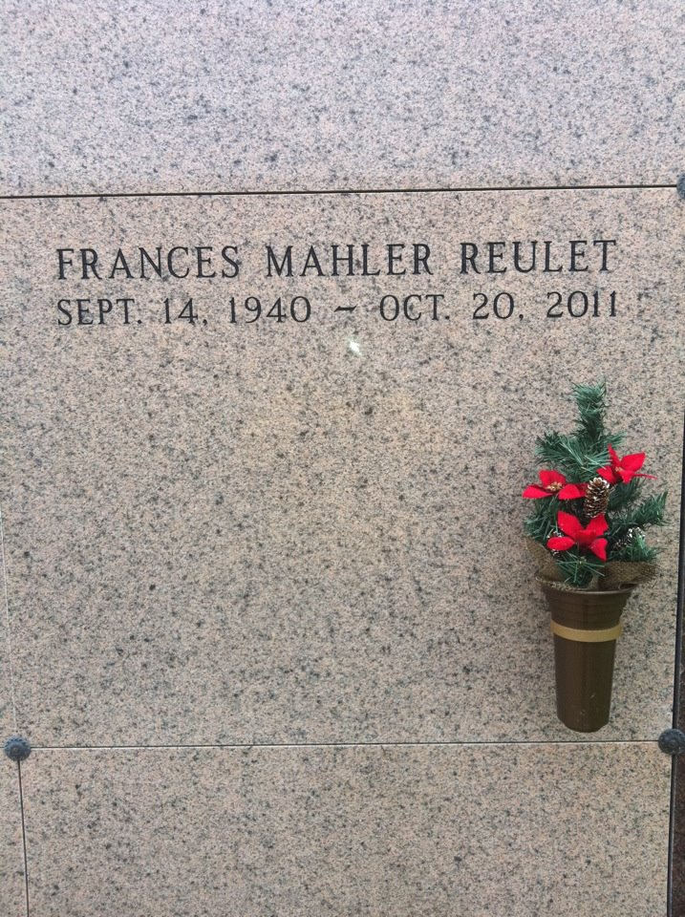

Photo by rrcar

Frances M. "Queenie" Reulet, age 71, entered into a peaceful world on Thursday, October 20, 2011 at her home. She was past president of the Ladies Auxiliary VFW Post 4245 in Vacherie, LA. Queenie loved to play bingo and go to the casino. She is survived by her loving husband, Antoine "Doc" Reulet; daughter, Robin R. Anderson and husband George; son, Darrell J. "T-Doc" Reulet and wife Sandra; grandson, Jacob Anderson; step grandson, Justin Hebert; step great-grandson, Gavin Hebert; three sisters: Mabler Morvant, Gertrude Simon-eaux, and Henrietta Landry; and four brothers: Alidore, Albert, Butley, and Lester Mahler. Preceded in death by her parents: Henry "DaDo" Mahler, Sr. and Florestine Durocher Mahler; daughter, Lisa Reulet; two sisters: Louise Constant and Jeanne Guidry; and five brothers: Louis "Jack", Claude, Norman, Henry Jr., and Vincent Mahler. Visitation will be held on Saturday, October 22, 2011 at Our Lady of Peace Church, Vacherie, LA from 8:00 a.m. until Mass of Christian Burial at 11:00 a.m. Celebrant Rev. Michael Miceli. Entombment to follow in Church Mausoleum.

Unknown source